FOOD CONNECT

To Supply Leftover Food To Poor

**Project Overview**:

*Food Connect* is a web-based and mobile-accessible platform aimed at minimizing food wastage by connecting individuals or organizations with surplus food to NGOs or volunteers who can distribute it to the poor and needy. The platform provides a simple, location-based system where food donors (like restaurants, event halls, or households) can post available leftover food, and nearby volunteers or NGOs can view, claim, and distribute that food.

By facilitating real-time communication, transparent tracking, and safe handling of food, *Food Connect* serves as a bridge between excess and hunger. It promotes sustainability, social responsibility, and community engagement through technology.

**Key Goals**:

* Reduce edible food waste.
* Feed the hungry by redirecting surplus food.
* Enable real-time donor-volunteer coordination.
* Ensure food safety and tracking through a user-friendly interface.

**Target Users**:

* Donors (Restaurants, Caterers, Individuals)
* Volunteers/NGOs
* Platform Administrators

**Outcome**:  
The system helps create a positive social impact by leveraging technology to ensure that no good food goes to waste while supporting communities in need.

**Objectives:**

The primary objective of the *Food Connect* project is to reduce the wastage of edible leftover food by establishing an efficient system that redistributes it to the poor and needy. This platform aims to connect food donors such as restaurants, households, and event organizers with nearby NGOs and volunteers who can collect and deliver the surplus food to underprivileged communities. By using real-time data and GPS-based location services, the platform ensures quick matching and coordination between donors and recipients.

The project also seeks to promote social responsibility among individuals and organizations, encouraging them to contribute toward reducing hunger and supporting community welfare. An important focus is placed on food safety and traceability, ensuring that donated food is safe for consumption and delivery activities are tracked from pickup to distribution. Additionally, the system will generate analytical reports to help monitor impact, identify high-demand zones, and guide future improvements. Ultimately, *Food Connect* is designed to be a scalable and sustainable solution that not only minimizes food waste but also fosters volunteer participation and builds a stronger, more compassionate society.

**Phase 1: Requirement Analysis & Planning:**

**● Understanding Business Requirements**:

The Food Connect platform aims to tackle two pressing social issues: food wastage and hunger. Donors, such as restaurants and individuals, often discard leftover food due to the absence of a structured system for redistribution. At the same time, many communities lack access to sufficient meals. This project was initiated to provide a centralized platform where donors can quickly report available food, and volunteers or organizations can access this information to arrange pickup and distribution.

During requirement analysis, it was identified that users need a simple, responsive system to post and claim food, real-time visibility of nearby donations, status tracking from pickup to delivery, and a mechanism for communication and updates. The system must be scalable, secure, and accessible across devices.

● **Defining Project Scope and Objectives:**

Scope:

* Build a platform that allows food donors to share details of available surplus food.
* Enable volunteers to view and claim food donations based on their location.
* Allow administrators to oversee all platform activity and user management.
* Automate status updates, alerts, and coordination through workflows.
* Generate insights on donation trends, volunteer performance, and delivery coverage.

Objectives:

* Reduce food wastage by enabling timely redistribution of surplus food.
* Facilitate a seamless connection between donors and volunteers using real-time data.
* Simplify food tracking from posting to final delivery.
* Ensure secure access and data privacy across all user roles.
* Promote social responsibility and volunteer engagement through a digital medium.

● **Design Data Model and Security Model:**

Data Model Design:  
The platform’s structure includes components to manage user information, food donation details, delivery activities, and system communications. These elements are linked together to support operations such as posting, claiming, updating status, and generating reports. The relationships between data entries are defined to ensure a smooth flow of information and traceability of every donation made.

Security Model Design:  
The system applies role-based access control, ensuring that each user (donor, volunteer, admin) has appropriate permissions. Donors can only manage their own contributions, while volunteers access donation listings and update their own deliveries. Administrators maintain full access to manage users and oversee the platform. Access to sensitive information is limited, and data visibility is controlled through carefully applied security settings. Authentication, validation rules, and secure channels ensure safe and reliable use of the platform.

**Phase 2: Salesforce Development – Backend & Configurations:**

**● Setup Environment & DevOps Workflow:**

In this phase, the development environment was prepared by setting up Salesforce sandboxes for configuration, testing, and deployment purposes. A structured DevOps workflow was followed to manage the development lifecycle efficiently. Changes were made in a developer sandbox and then promoted to a test environment before final deployment to production. Source control tools were used to track changes, and Salesforce Change Sets or deployment tools like Salesforce CLI were used to migrate configurations and code.

This ensured a clean separation between development, testing, and production environments, minimizing risks and allowing for structured reviews and rollback if necessary.

● **Customization of Objects, Fields, Validation Rules, and Automation:**

**Create Venue Object**

To create an object:

1. From the setup page >> Click on Object Manager >> Click on Create >>Click on Custom Object.

* Enter the label name >> Venue
* Plural label name >> Venues
* Enter Record Name Label and Format

1.Record Name >> Venue Name

2.Data Type >> Text

2.Click on Allow reports and Track Field History, Allow Activities.

3.Allow search >> Save.

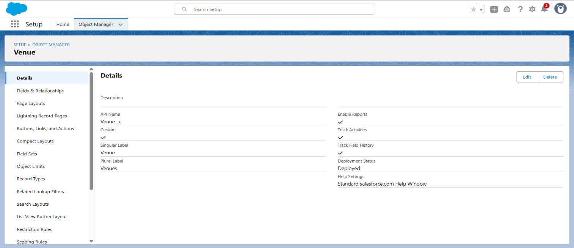

**Create Drop-Off Point Object**

To create an object:

1. From the setup page >> Click on Object Manager >> Click on Create >> Click on Custom Object.

* Enter the label name >> Drop-Off Point
* Plural label name>> Drop-Off Points
* Enter Record Name Label and Format

a. Record Name >> Drop-Off point Name

b. Data Type >> Text

2. Click on Allow reports and Track Field History, Allow Activities

3. Allow search >> Save.

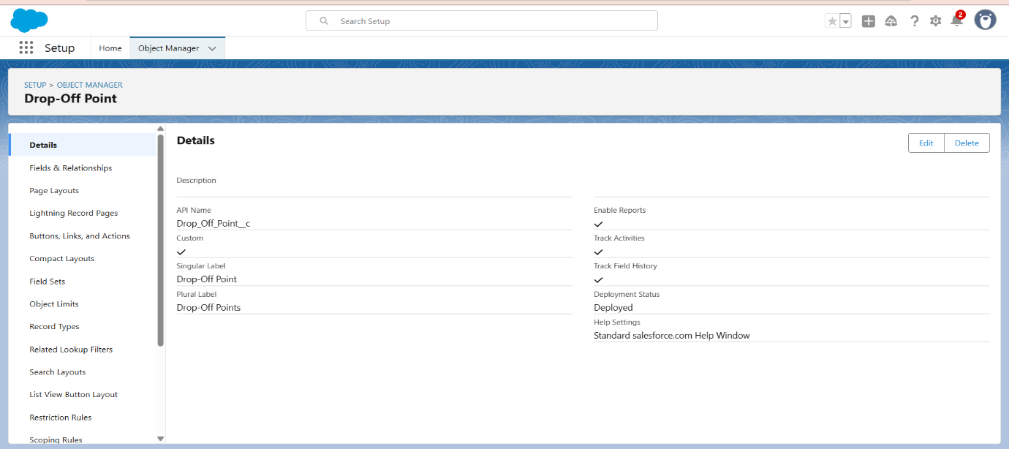

**Create Task Object**

To create an object:

1. From the setup page >> Click on Object Manager >> Click on Create >> Click on Custom Object.
2. Enter the label name>> Task
3. Plural label name>> Tasks
4. Enter Record Name Label and Format

* Record Name >> Task Name
* Data Type >> Text

2. Click on Allow reports and Track Field History,Allow Activities

3. Allow search >> Save.

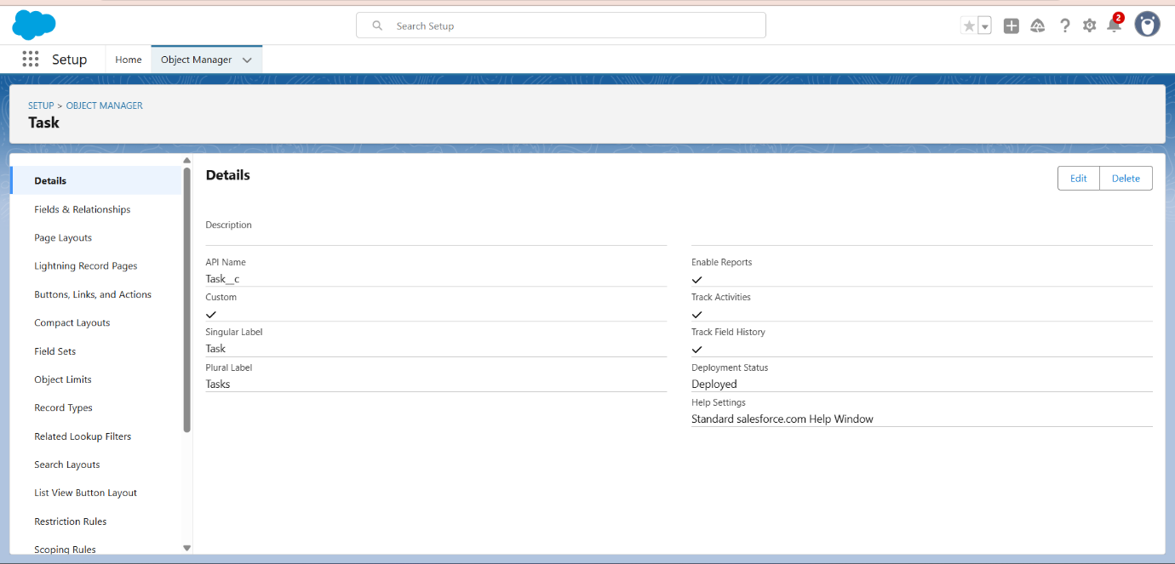

**Create Volunteer Object**

To create an object:

1. From the setup page >> Click on Object Manager>> Click on Create >> Click on Custom Object.
2. Enter the label name>> Volunteer
3. Plural label name>> Volunteers
4. Enter Record Name Label and Format

* Record Name >> Volunteer Name
* Data Type >> Text

2. Click on Allow reports and Track Field History, Allow Activities

3. Allow search >> Save.

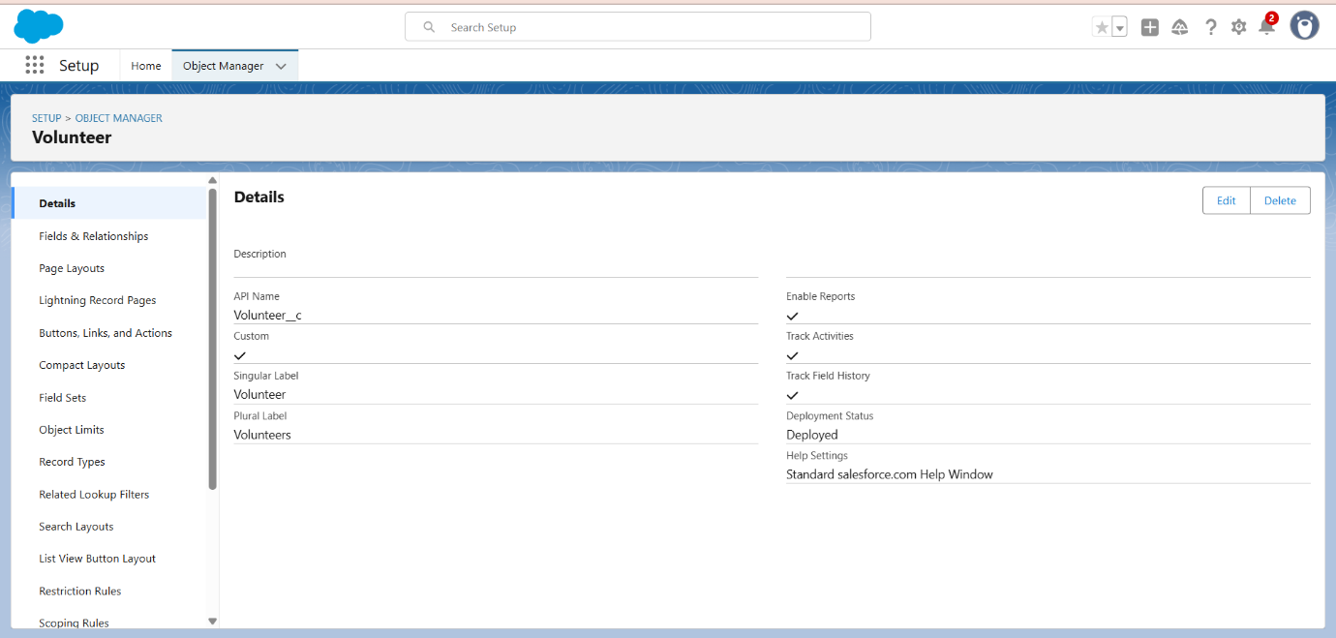

**Create Execution Detail Object**

To create an object:

1. From the setup page >> Click on Object Manager >> Click on Create >> Click on Custom Object.
2. Enter the label name >> Execution Detail
3. Plural label name >> Execution Details
4. Enter Record Name Label and Format

* Record Name >> Execution Detail Name
* Data Type >> Text

1. Click on Allow reports and Track Field History, Allow Activities
2. Allow search >> Save.

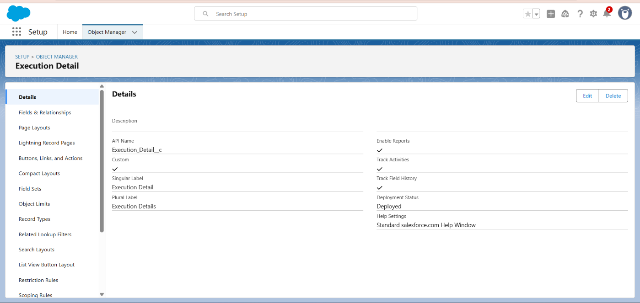

**Creation of Relationship fields in objects**

Creation of Lookup Relationship Field on Volunteer Object:

1. Go to setup >> click on Object Manager >> type object name (Volunteer) in the search bar >> click on the object.
2. Now click on “Fields & Relationships” >> New
3. Select Master Detail relationship
4. Select the related object “Drop-Off point” and click next.
5. Field Name: Drop_off point
6. Field label: Auto generated
7. Next >> Next >> Save.

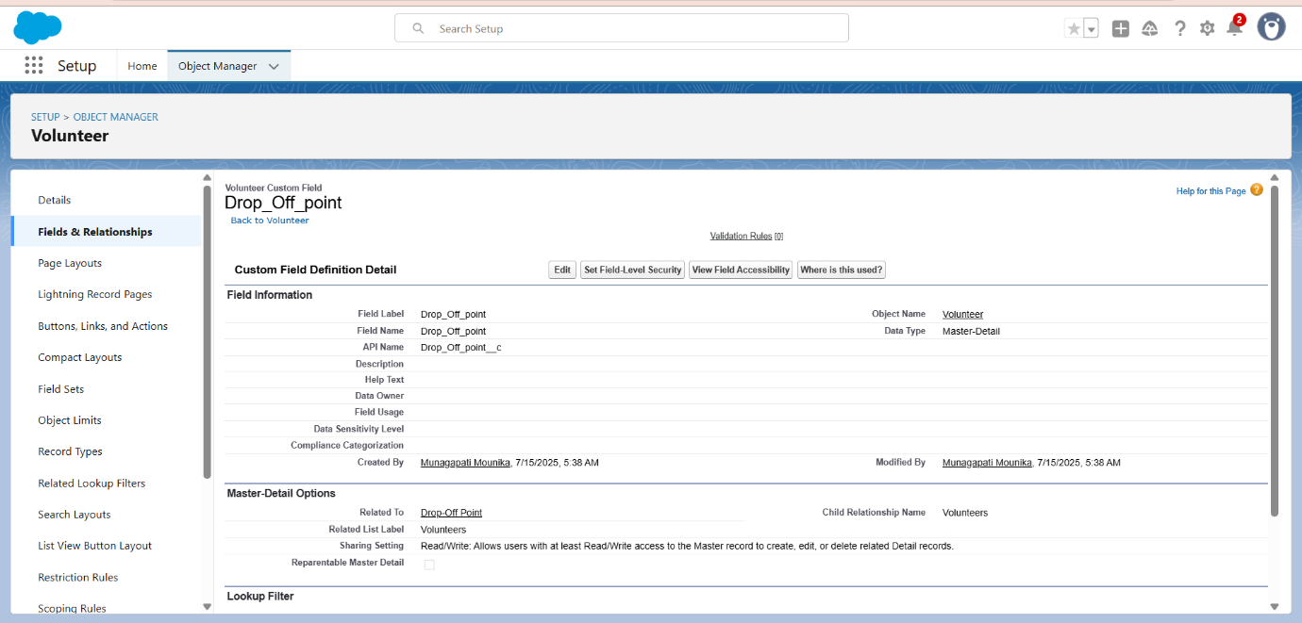

Creation of Master Detail Relationship Field on Execution Details Object:

1. Go to setup >> click on Object Manager >> type object name (Execution Details) in the search bar >> click on the object.
2. Now click on “Fields & Relationships” >> New
3. Select Master Detail relationship
4. Select the related object “Volunteer” and click next.
5. Field Name: Volunteer
6. Field label: Auto generated
7. Next >> Next >> Save.

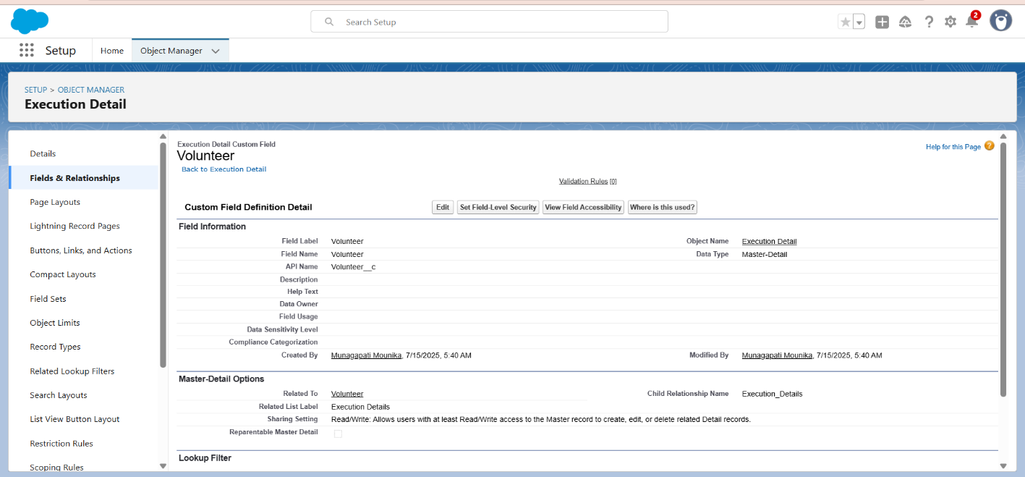

Creation of Master Detail Relationship Field on Execution Details Object :

1. Go to setup >> click on Object Manager >> type object name(Execution Details) in the search bar >> click on the object.
2. Now click on “Fields & Relationships” >> New
3. Select Master Detail relationship
4. Select the related object “Task” and click next.
5. Field Name: Task
6. Field label: Auto generated
7. Next >> Next >> Save.

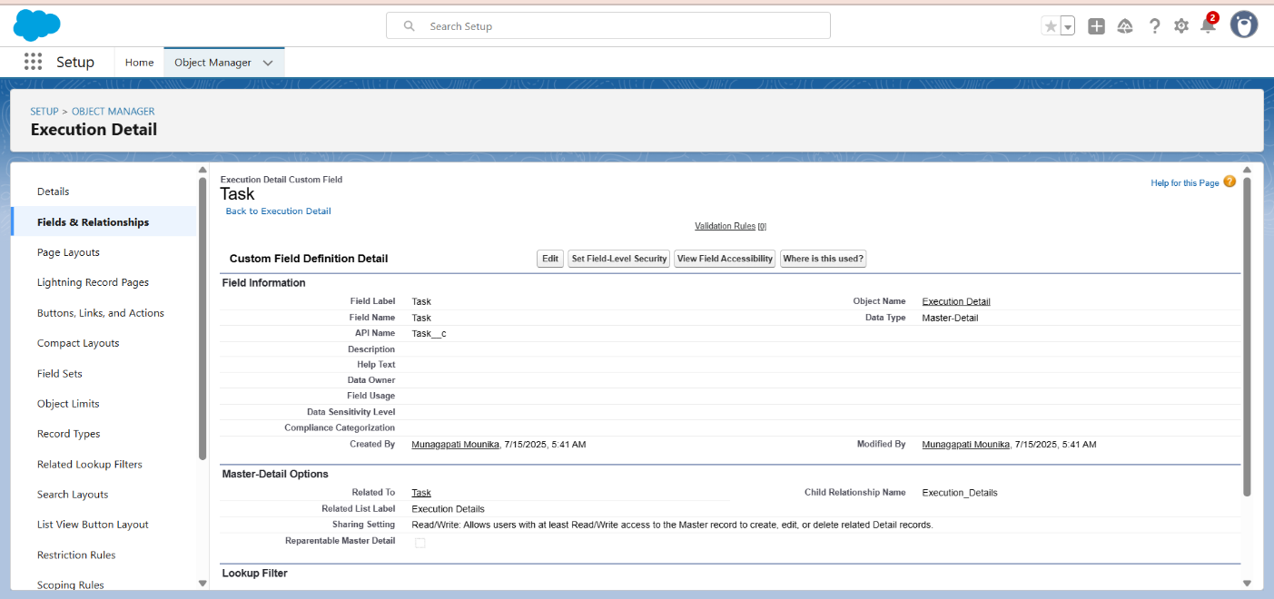

Creation of Lookup Relationship Field on Drop-Off Point Object:

1. Go to setup >> click on Object Manager >> type object name (Drop-Off Point) in the search bar >> click on the object.
2. Now click on “Fields & Relationships” >> New
3. Select Lookup relationship
4. Select the related object “Venue” and click next.
5. Field Name: Venue
6. Field label: Venue__c
7. Next >> Next >> Save.

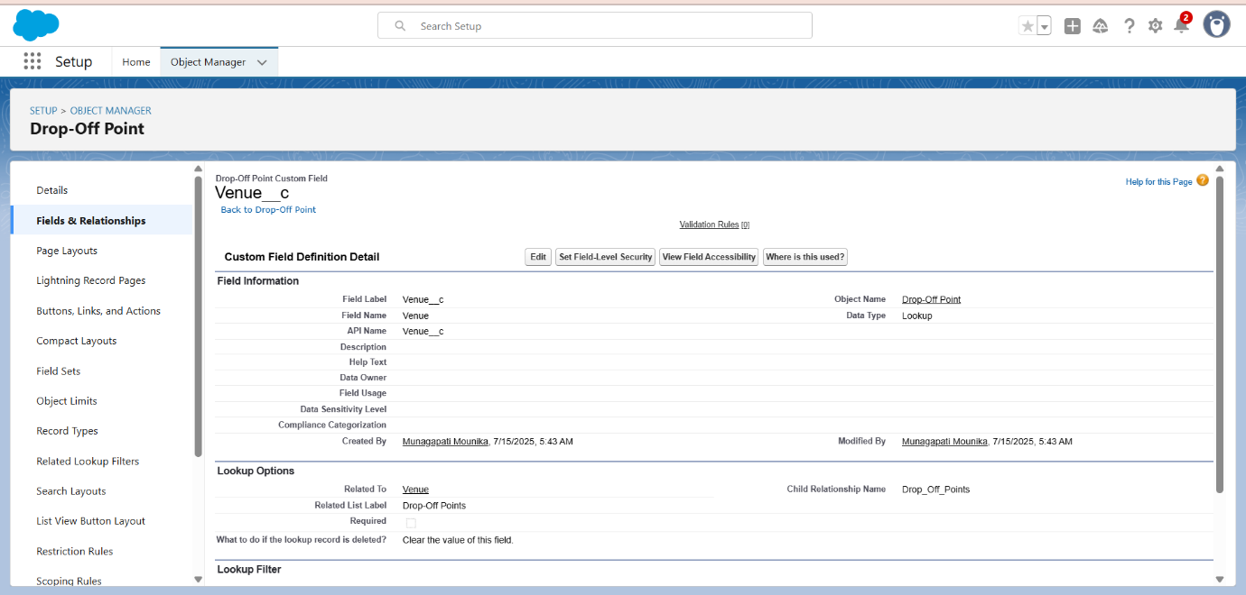

Creation of Lookup Relationship Field on Task Object:

1. Go to setup>> click on Object Manager >> type object name (Task) in the search  bar >> click on the object.
2. Now click on “Fields & Relationships” >> New
3. Select Lookup relationship
4. Select the related object “Venue” and click next.
5. Field Name: Sponsored By
6. Field label: Auto generated
7. Next >> Next >> Save.

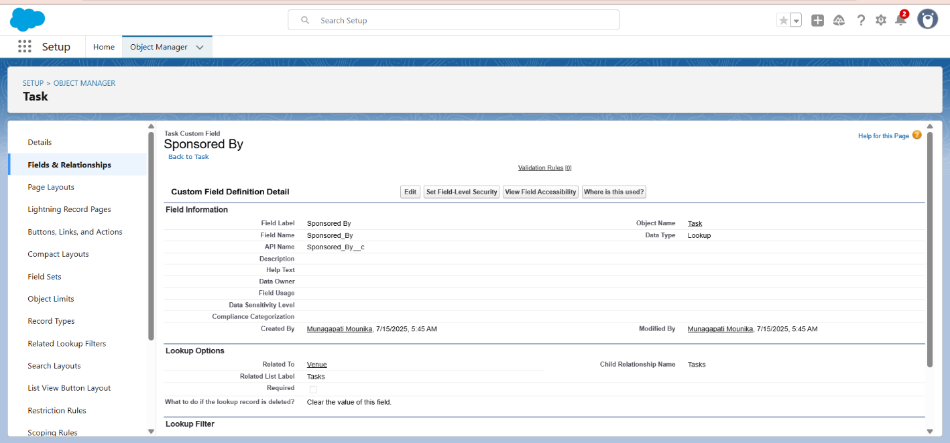

Creation of Lookup Relationship Field on Task Object:

1. Go to setup>> click on Object Manager >> type object name(Task) in the search bar >> click on the object.
2. Now click on “Fields & Relationships” >> New
3. Select Lookup relationship
4. Select the related object “Drop-Off point” and click next.
5. Field Name: Drop-Off point
6. Field label: Auto generated
7. Next >> Next >> Save.

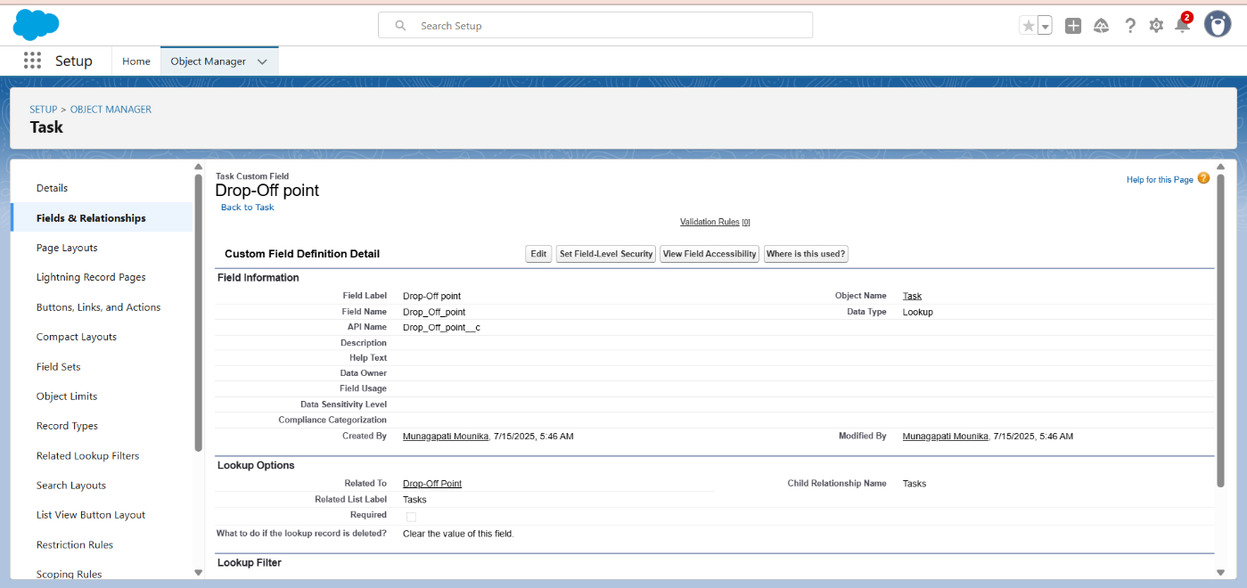

**Creation of fields for the Venue object**

1. Go to setup>> click on Object Manager >> type object name(Venue) in search bar >> click on the object.
2. Now click on “Fields & Relationships” >> New
3. Select Data type as a “Email” and Click on Next
4. Fill the Above as following:

* Field Label: Contact Email
* Field Name: Contact Email
* Click on required check box
* Click on Next >> Next >> Save and new.

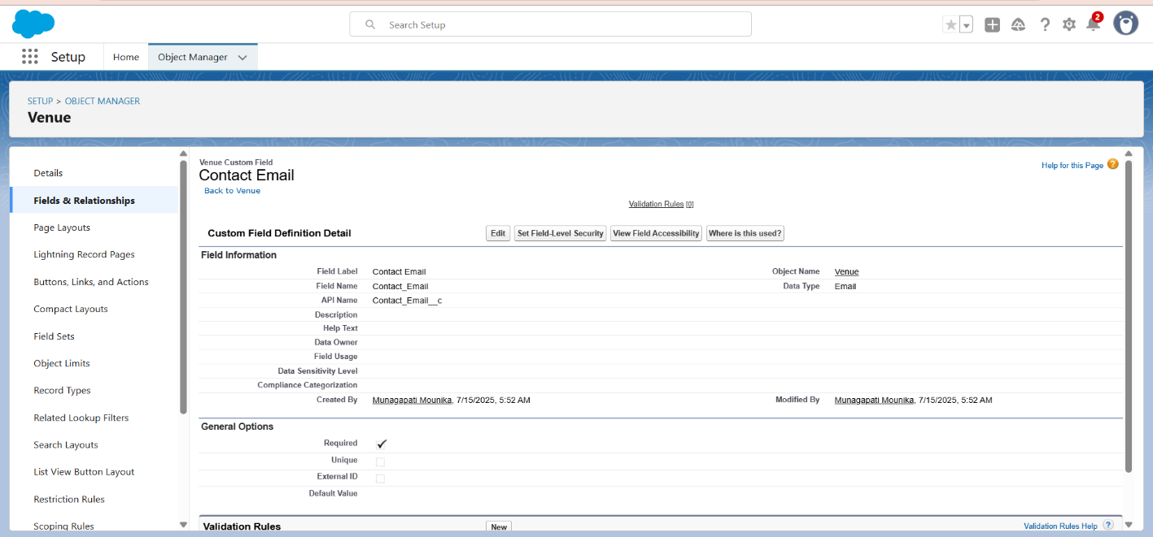

**To create another fields in an object:**

1. Go to setup >> click on Object Manager >> type object name(Venue) in search bar >> click on the object.
2. Now click on “Fields & Relationships” >> New
3. Select Data type as a “Phone” and Click on Next

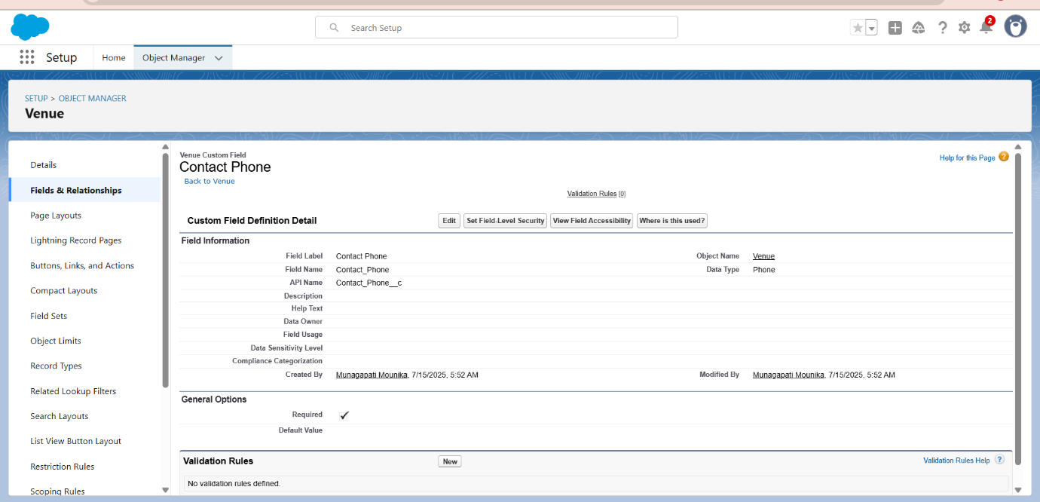

1. Fill the Above as following:

* Field Label: Contact Phone
* Field Name: Contact Phone
* Click on required check box
* Click on Next >> Next >> Save and new.

**To create another fields in an object:**

1. Go to setup >> click on Object Manager >> type object name(Venue) in search bar >>click on the object.
2. Now click on “Fields & Relationships” >> New
3. Select Data type as a “Geolocation” and Click on Next

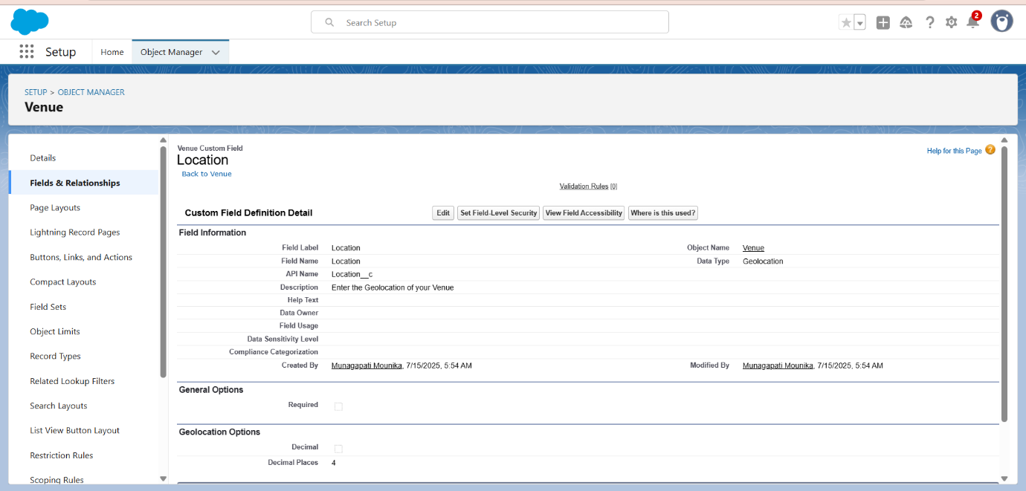

1. Fill the Above as following:

* Field Label: Location
* Decimal Places: 4
* Field Name: Location
* Description: Enter the Geolocation of your Venue
* Click on Next >> Next >> Save and new.

To create other fields in an object:

1. Go to setup >> click on Object Manager >> type object name(Venue) in search bar >> click on the object.
2. Now click on “Fields & Relationships” >> New
3. Select Data type as a “Long Text Area” and Click on Next

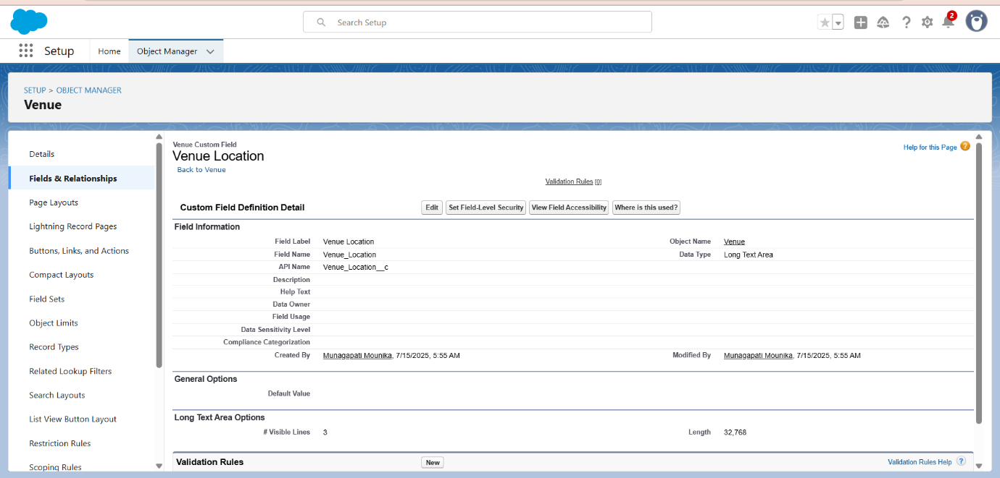

1. Fill the Above as following:

* Field Label : Venue Location
* Field Name : Venue_Location
* Click on Next >> Next >> Save and new.

**Creation of fields for the Drop-Off point object**

Go to setup >> click on Object Manager >> type object name(Drop-Off point) in search bar >> click on the object.

2. Now click on “Fields & Relationships” >> New

3. Select Data type as a “Geolocation” and Click on Next

4. Fill the Above as following:

* Field Label: Location 2
* Field Name: gets auto generated
* Description: Enter the Geolocation of the Drop off Point
* Geolocation Options: select Decimal
* Decimal Places: 4
* Click on Next >> Next >> Save and new.

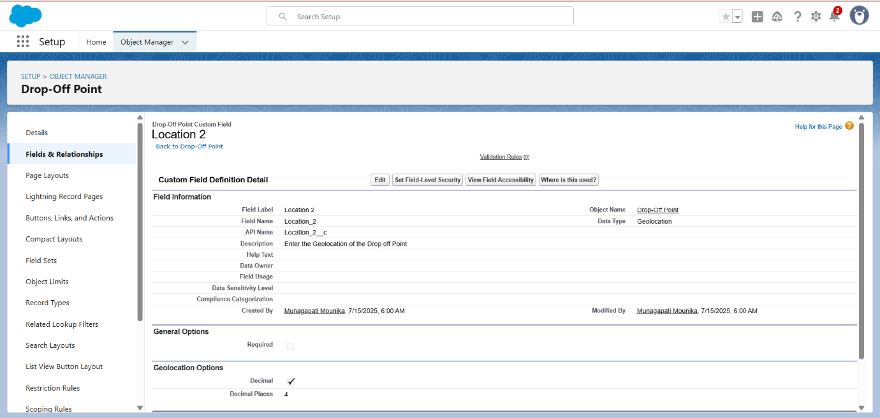

To create another fields in an object:

1. Go to setup >> click on Object Manager >> type object name (Drop-Off point) in search bar >> click on the object.
2. Now click on “Fields & Relationships” >> New
3. Select Data type as a “Formula” and Click on Next

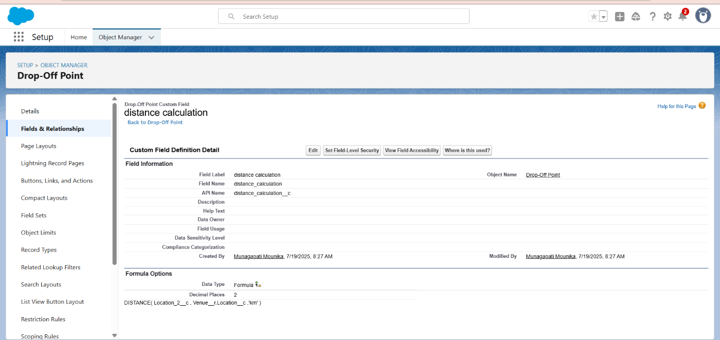

1. Fill the Above as following:

* Field Label: distance calculation
* Field Name: distance_calculation
* Formula Return Type: Number
* Formula Options: DISTANCE( Location_2__c ,  Venue__r.Location__c , 'km')
* Click on Next >> Next >> Save and new.

To create another fields in an object:

1. Go to setup >> click on Object Manager >> type object name (Drop-Off point) in search bar >> click on the object.
2. Now click on “Fields & Relationships” >> New
3. Select Data type as a “Picklist” and Click on Next
4. Fill the Above as following:

* Field Label: State
* Field Name: State
* Enter values, with each value separated by a new line:

Andhra Pradesh

Arunachal Pradesh

Assam

Bihar

Chhattisgarh

Goa

Gujarat

Haryana

Himachal Pradesh

Jharkhand

Karnataka

Kerala

Maharashtra

Madhya Pradesh

Manipur

Meghalaya

Mizoram

Nagaland

Odisha

Punjab

Rajasthan

Sikkim

Tamil Nadu

Tripura

Telangana

Uttar Pradesh

Uttarakhand

West Bengal

Andaman & Nicobar (UT)

Chandigarh (UT)

Dadra & Nagar Haveli and Daman & Diu (UT)

Delhi [National Capital Territory (NCT)]

Jammu & Kashmir (UT)

Ladakh (UT)

Lakshadweep (UT)

Puducherry (UT)

* Click on required check box
* Click on Next >> Next >> Save and new.
* Click on Next >> Next >> Save and new.

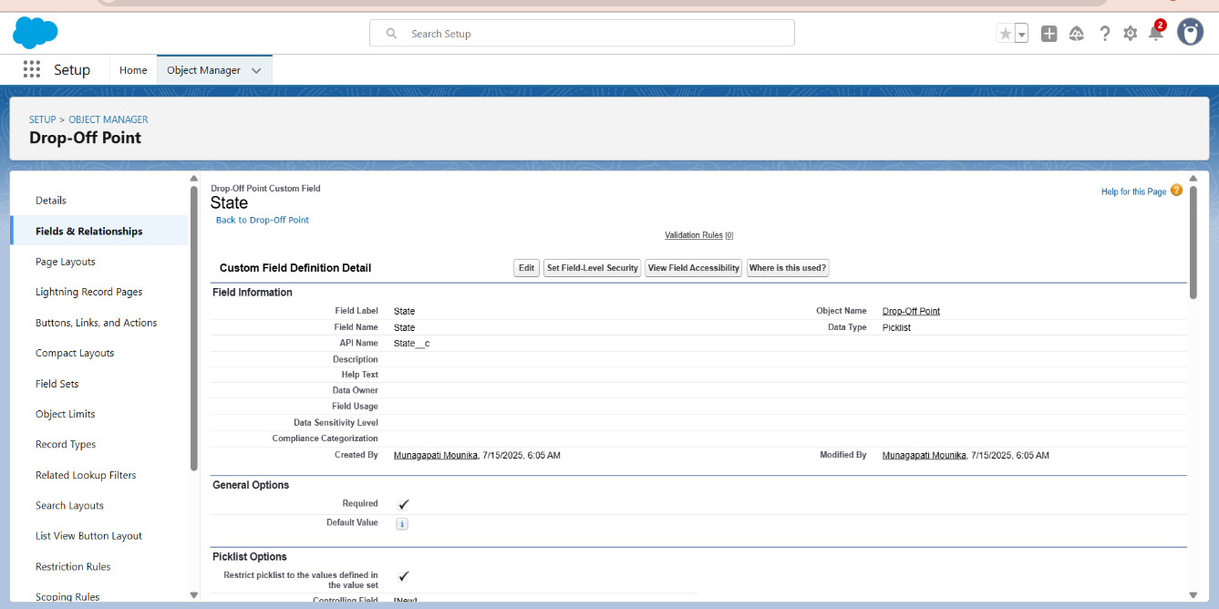

To create another fields in an object:

1. Go to setup >> click on Object Manager >> type object name(Drop-Off point) in search bar >> click on the object.
2. Now click on “Fields & Relationships” >> New
3. Select Data type as a “Number” and Click on Next

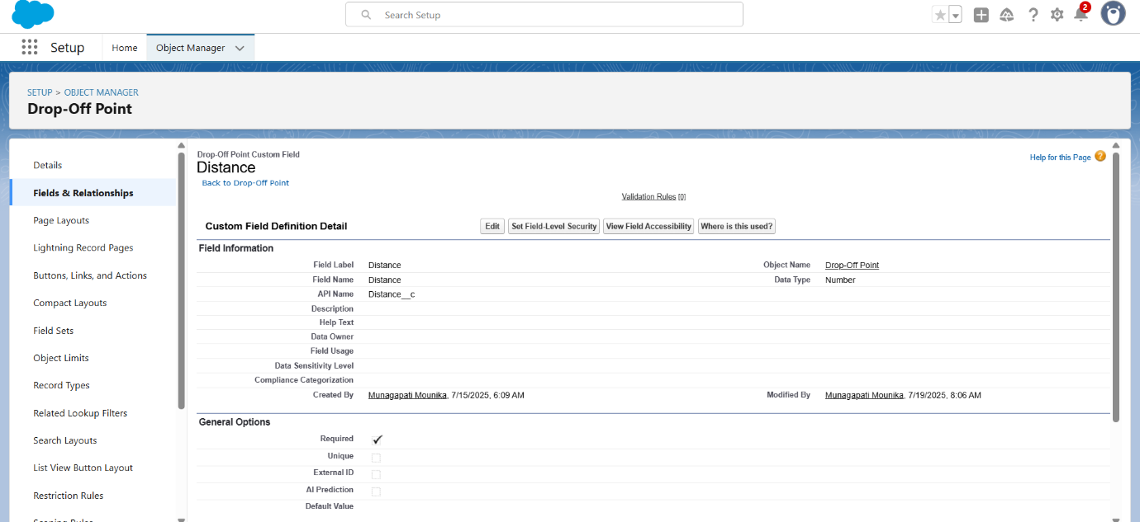

1. Fill the Above as following:

* Field Label: Distance
* Field Name: Distance
* Length: 14
* Decimal Places: 4
* Click on required check box
* Click on Next >> Next >> Save and new.

**Creation of fields for the Task object**

Go to setup>> click on Object Manager >> type object name (Task) in search bar >> click on the object.

2. Now click on “Fields & Relationships” >> New

3. Select Data type as a “Auto Number” and Click on Next

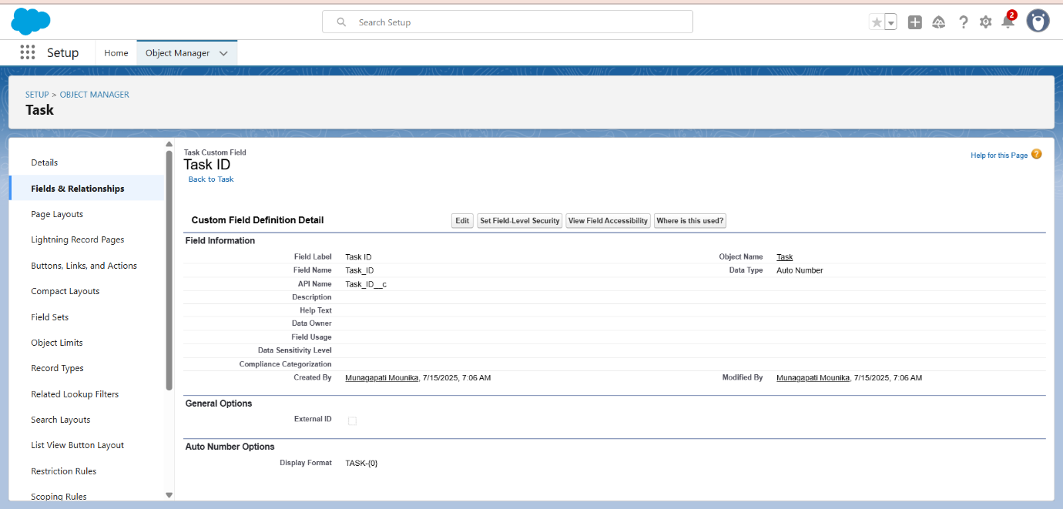

4. Fill the Above as following:

* Field Label: Task ID
* Display Format: TASK- {0}
* Starting Number: 1
* Field Name: gets auto generated
* Click on required check box
* Click on Next >> Next >> Save and new.

To create another fields in an object:

1. Go to setup >> click on Object Manager >> type object name(Task) in search bar >> click on the object.
2. Now click on “Fields & Relationships” >> New
3. Select Data type as a “Date” and Click on Next

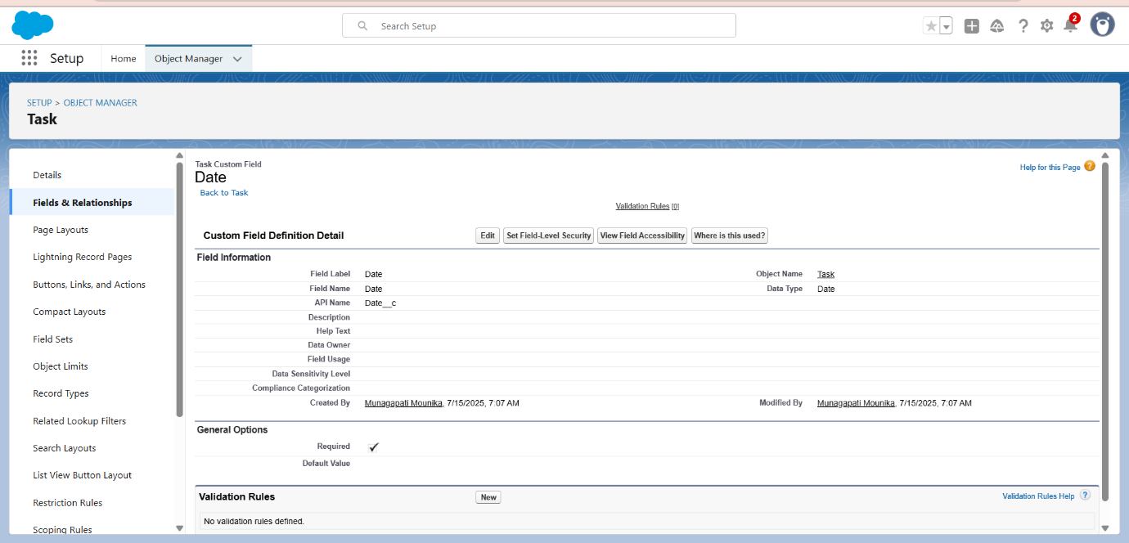

1. Fill the Above as following:

* Field Label: Date
* Field Name: Date
* Click on required check box
* Click on Next >> Next >> Save and new.

To create another fields in an object:

1. Go to setup >> click on Object Manager >> type object name (Task) in search bar >> click on the object.
2. Now click on “Fields & Relationships” >> New
3. Select Data type as a “Picklist (Multi-Select)” and Click on Next

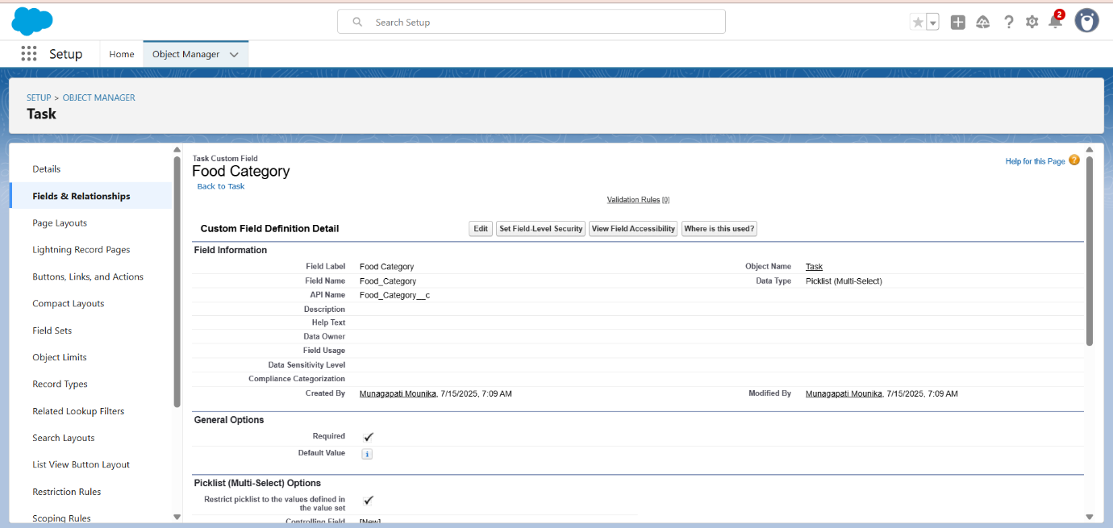

1. Fill the Above as following:

* Field Label: Food Category
* Field Name: Food Category
* Enter values, with each value separated by a new line :

Veg

Non-Veg

Salad

Snack

* Click on required check box
* Click on Next >> Next >> Save and new.

To create another fields in an object:

1. Go to setup >> click on Object Manager >> type object name(Task) in search bar >> click on the object.
2. Now click on “Fields & Relationships” >> New
3. Select Data type as a “Number” and Click on Next

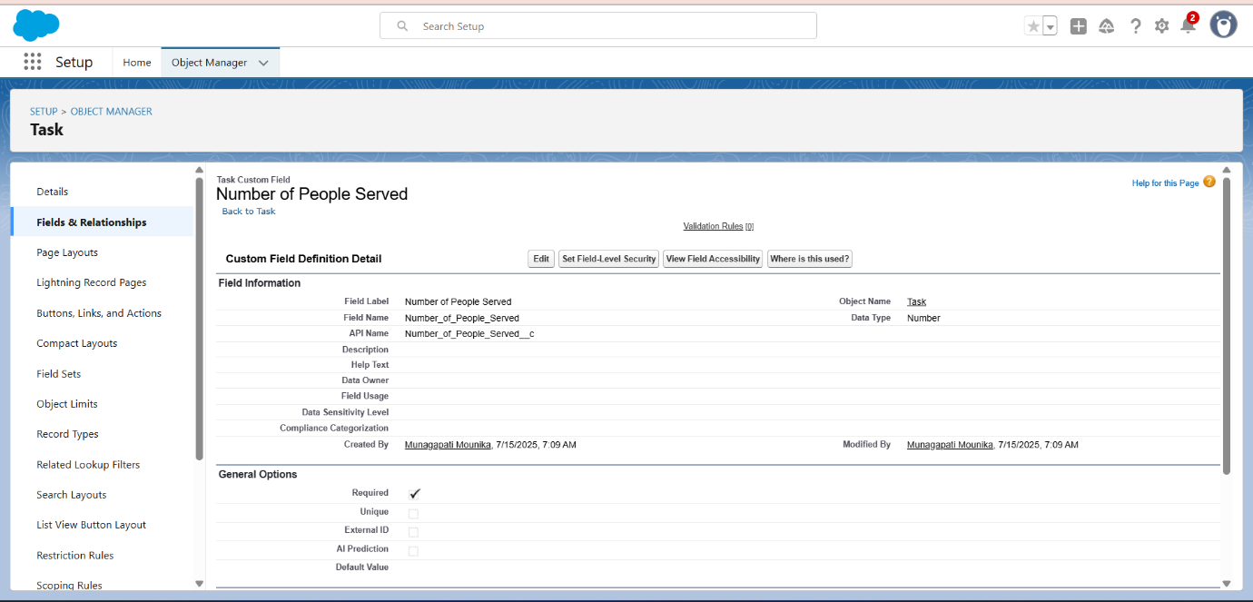

1. Fill the Above as following:

* Field Label: Number of People Served
* Field Name: Number_of_People_Served
* Click on required check box
* Click on Next >> Next >> Save and new.

To create another fields in an object:

1. Go to setup >> click on Object Manager >> type object name(Task) in search bar >> click on the object.
2. Now click on “Fields & Relationships” >> New
3. Select Data type as a “Text” and Click on Next
4. Fill the Above as following:

* Field Label: Name of the Person
* Field Name: Name_of_the_Person
* Click on Next >> Next >> Save and new.

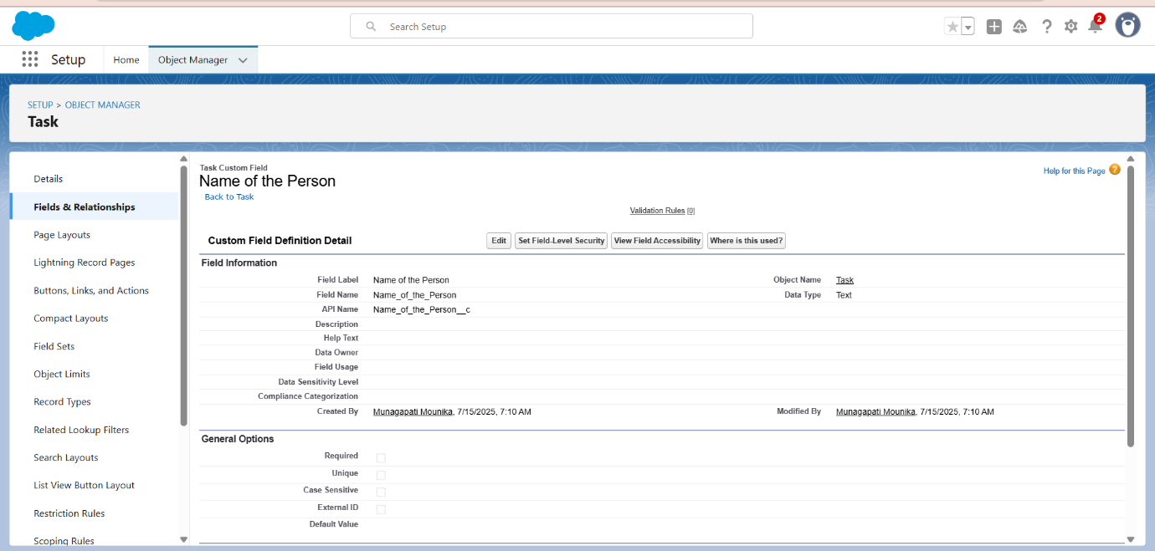

To create another fields in an object:

1. Go to setup>> click on Object Manager >> type object name(Task) in search bar >> click on the object.
2. Now click on “Fields & Relationships” >> New
3. Select Data type as a “Phone” and Click on Next

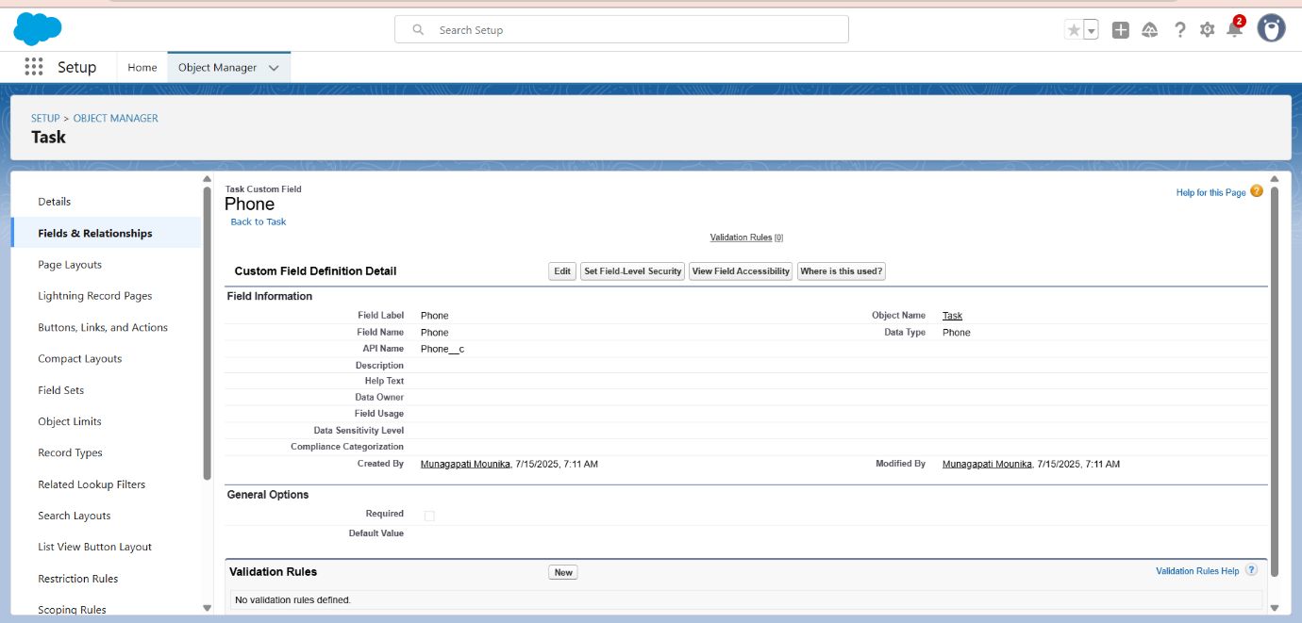

1. Fill the Above as following:

* Field Label: Phone
* Field Name: Phone
* Click on Next >> Next>> Save and new.

To create another fields in an object:

1. Go to setup >> click on Object Manager >> type object name(Task) in search bar >> click on the object.
2. Now click on “Fields & Relationships” >> New
3. Select Data type as a “Pick List” and Click on Next

1.

2.

3

4

5

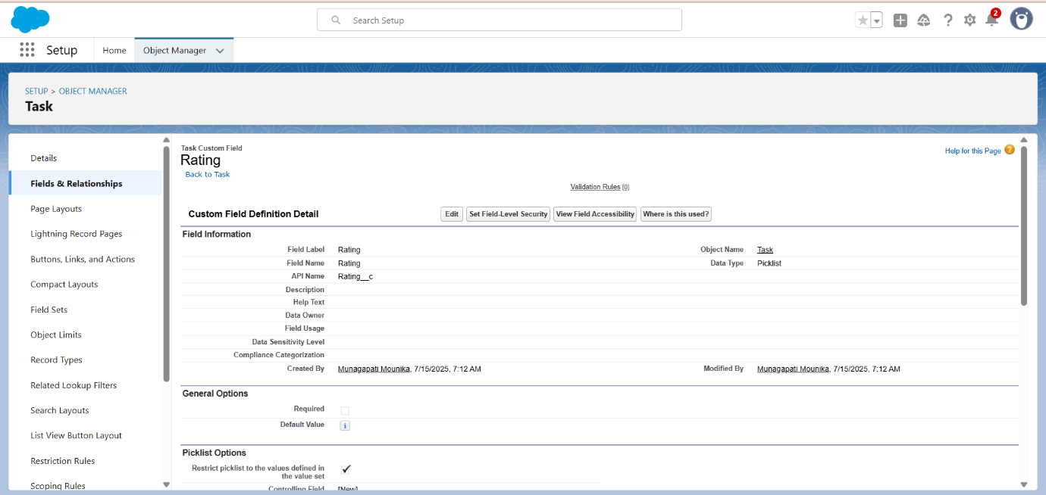

1. Fill the Above as following:

* Field Label: Rating
* Field Name: Rating
* Enter values, with each value separated by a new line:
* Click on Next >> Next >> Save and new.

To create another fields in an object:

1. Go to setup >> click on Object Manager >> type object name (Task) in search bar >> click on the object.
2. Now click on “Fields & Relationships” >> New
3. Select Data type as a “Long Text Area” and Click on Next
4. Fill the Above as following:

* Field Label: Feedback
* Field Name: Feedback
* Click on Next >> Next >> Save and new.

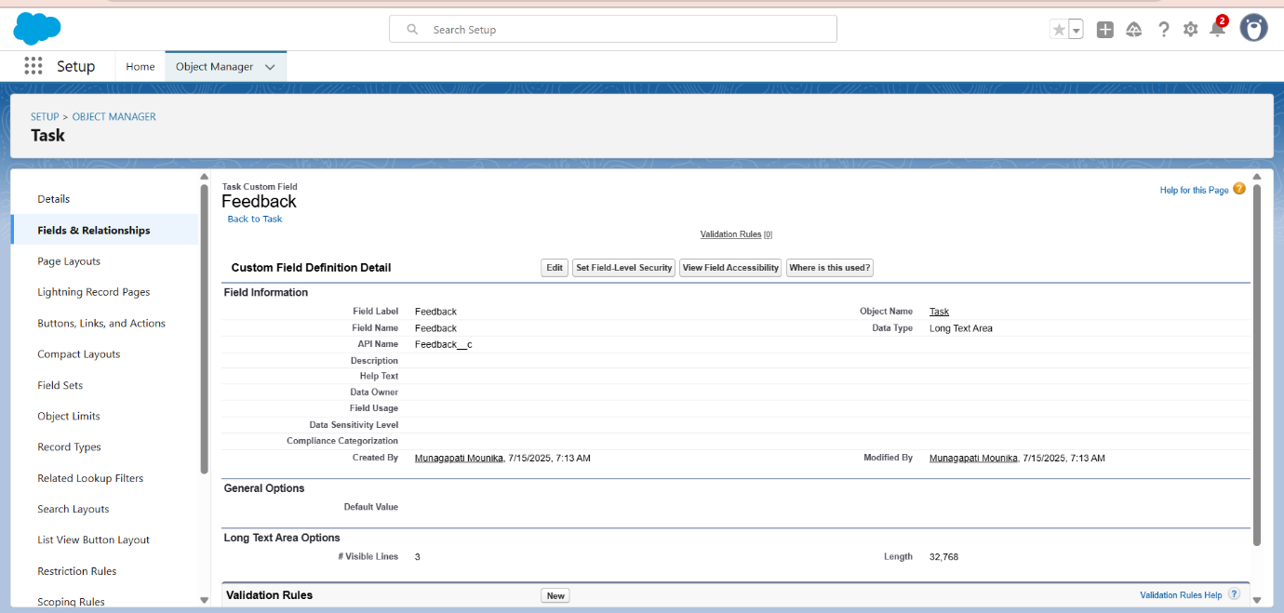

**Creation of fields for the Volunteer object**

1. Go to setup >> click on Object Manager >> type object name(Volunteer) in search bar >> click on the object.

2. Now click on “Fields & Relationships” >> New

3. Select Data type as a “Auto Number” and Click on Next

4. Fill the Above as following:

* Field Label : Volunteer ID
* Field Name : gets auto generated
* Click on required check box
* Click on Next >> Next >> Save and new.
* Click on Next >> Next >> Save and new.

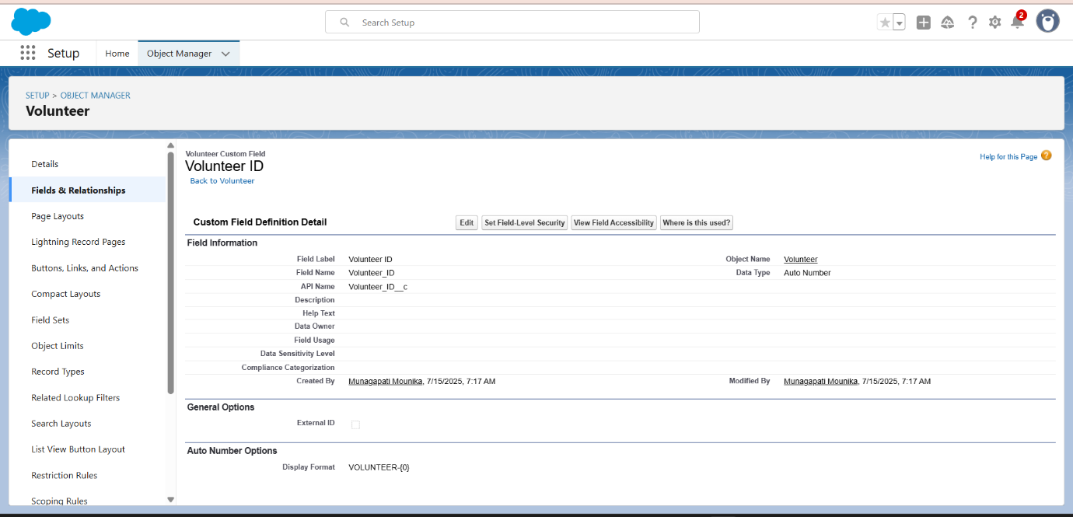

To create another fields in an object:

1. Go to setup >> click on Object Manager >> type object name(Volunteer) in search bar >> click on the object.
2. Now click on “Fields & Relationships” >> New
3. Select Data type as a “Picklist” and Click on Next
4. Fill the Above as following:

* Field Label : Gender
* Field Name : Gender
* Enter values, with each value separated by a new line :

Female

Male

* Click on Next >> Next >> Save and new.

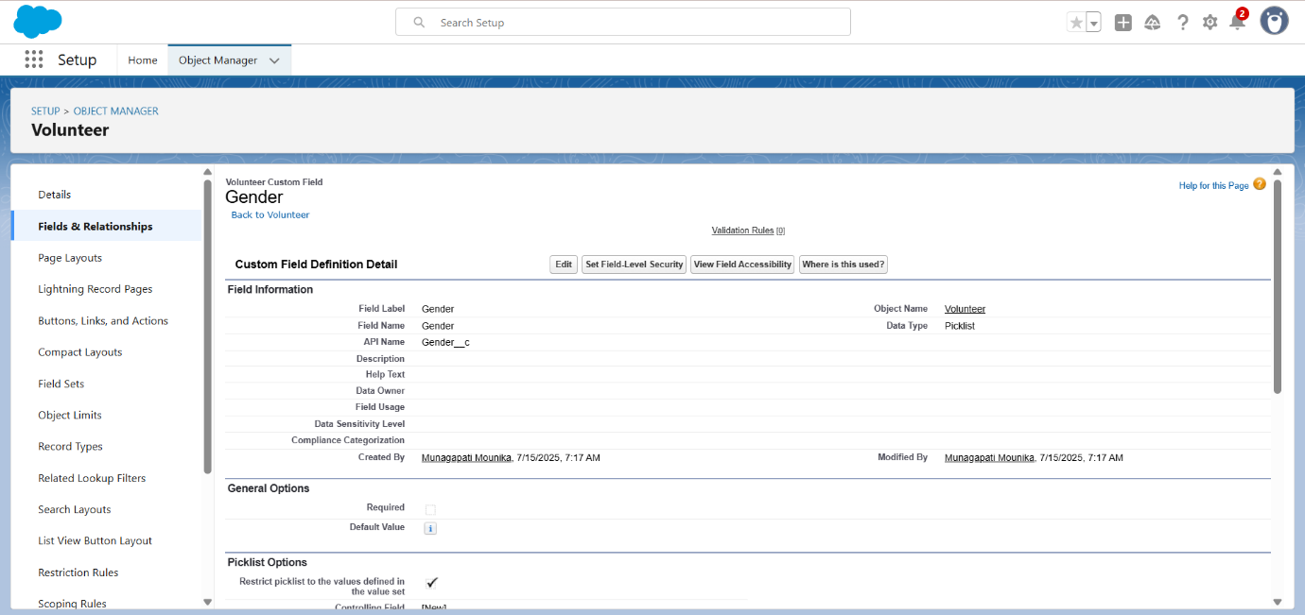

To create another fields in an object:

1. Go to setup >> click on Object Manager >> type object name(Volunteer) in search bar >> click on the object.
2. Now click on “Fields & Relationships” >> New
3. Select Data type as a “Date” and Click on Next
4. Fill the Above as following:

* Field Label : Available On
* Field Name : Available On
* Click on required check box
* Click on Next >> Next >> Save and new.

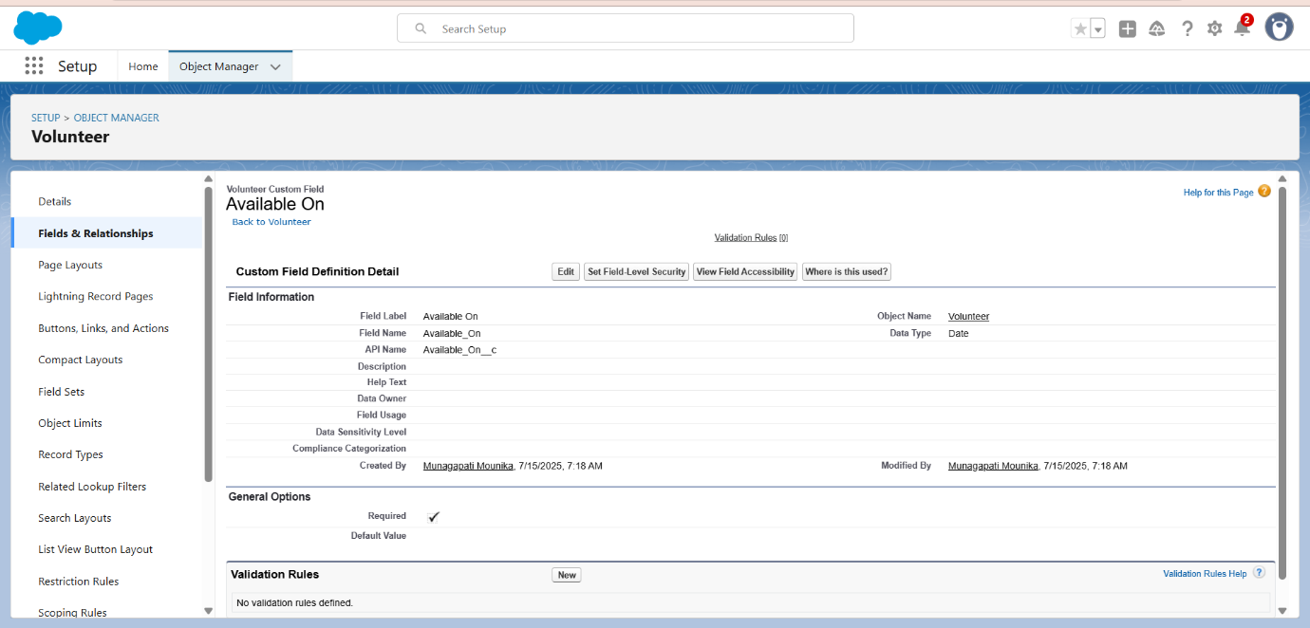

To create another fields in an object:

1. Go to setup >> click on Object Manager >> type object name(Volunteer) in search bar >> click on the object.
2. Now click on “Fields & Relationships” >> New
3. Select Data type as a “Number” and Click on Next
4. Fill the Above as following:

* Field Label : Age
* Field Name : Age
* Click on required check box
* Click on Next >> Next>> Save and new.

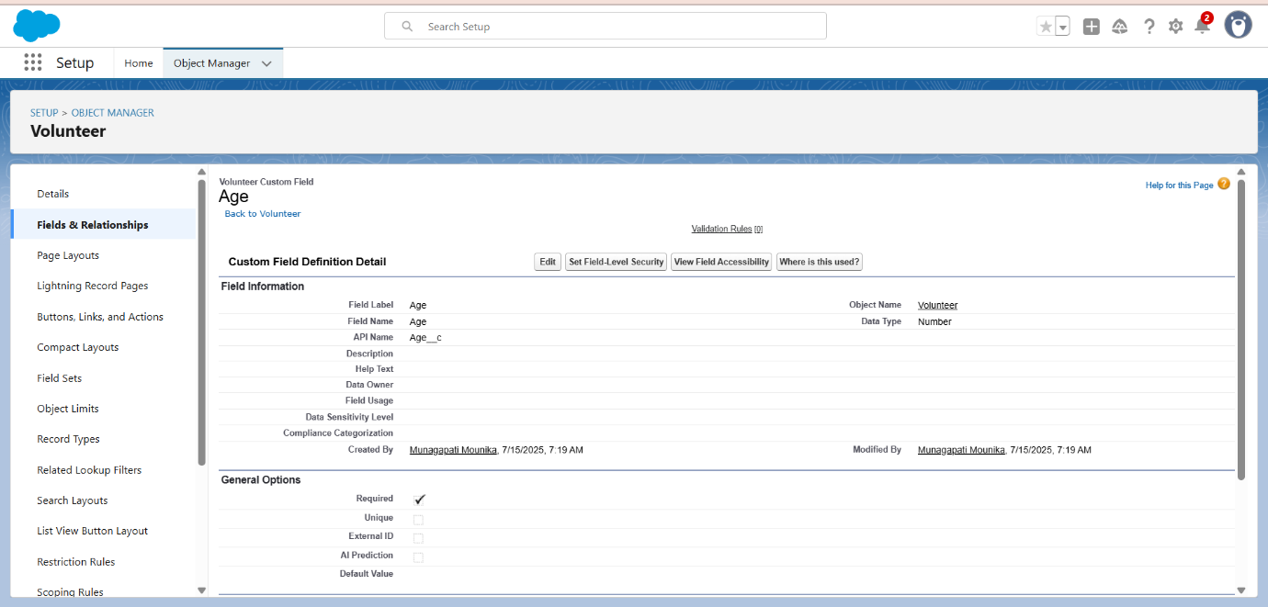

To create another fields in an object:

1. Go to setup >> click on Object Manager >> type object name(Volunteer) in search bar >> click on the object.
2. Now click on “Fields & Relationships” >> New
3. Select Data type as a “Email” and Click on Next
4. Fill the Above as following:

* Field Label : Email
* Field Name : Email
* Click on required check box
* Click on Next>> Next >> Save and new.

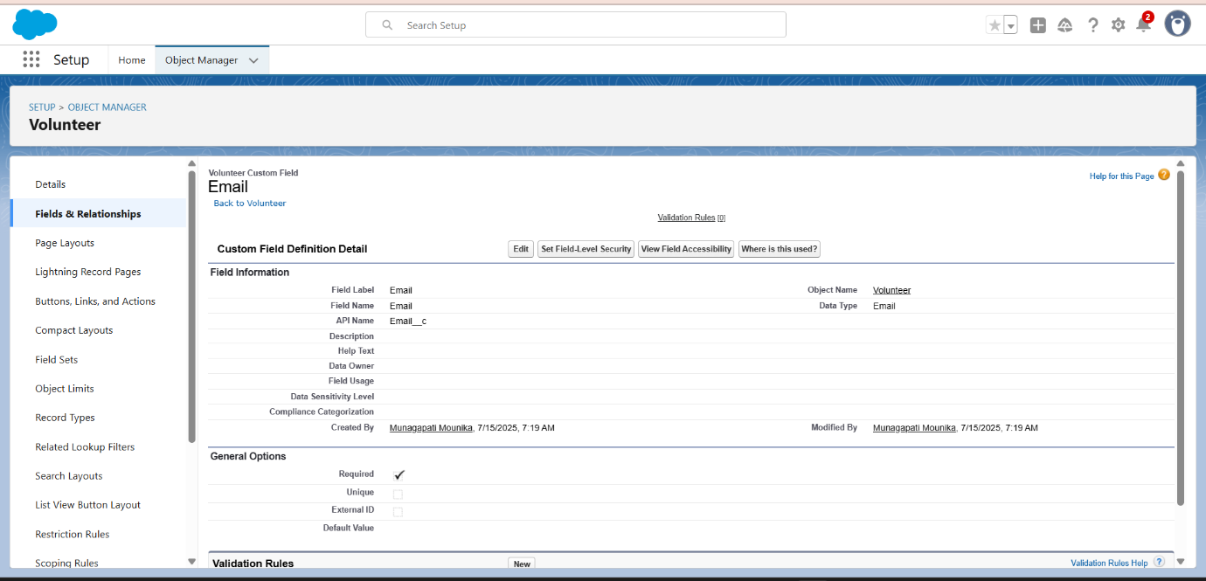

To create another fields in an object:

1. Go to setup >> click on Object Manager >> type object name(Volunteer) in search bar >> click on the object.
2. Now click on “Fields & Relationships” >> New
3. Select Data type as a “Number” and Click on Next
4. Fill the Above as following:

* Field Label : Contact Number
* Field Name : Contact_Number
* Click on required check box
* Click on Next >> Next >> Save and new.

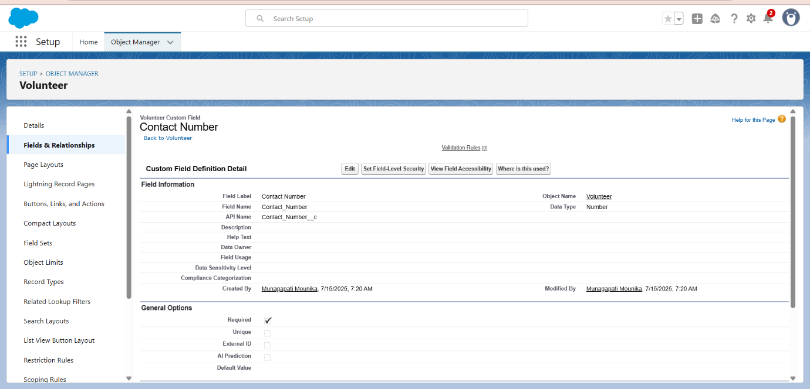

To create another fields in an object:

1. Go to setup >> click on Object Manager >> type object name(Volunteer) in search bar >> click on the object.
2. Now click on “Fields & Relationships” >> New
3. Select Data type as a “Text Area (Long)” and Click on Next
4. Fill the Above as following:

* Field Label : Address
* Field Name : Address
* Click on Next >> Next >> Save and new.

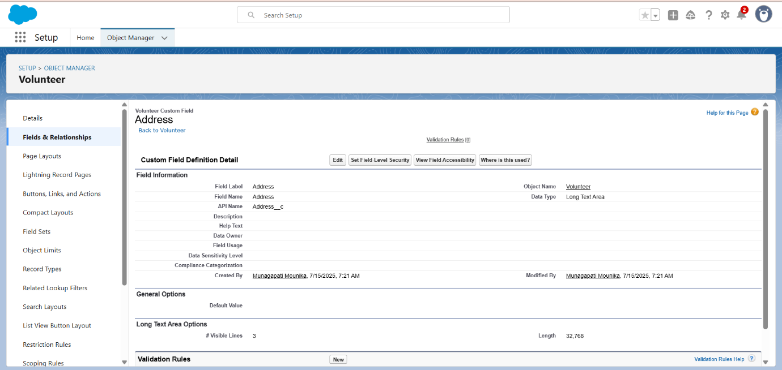

To create another fields in an object:

1. Go to setup >> click on Object Manager >> type object name(Volunteer) in search bar >> click on the object.
2. Now click on “Fields & Relationships” >> New
3. Select Data type as a “Date” and Click on Next
4. Fill the Above as following:

* Field Label : Date of Birth
* Field Name : Date_of_Birth
* Click on Next >> Next >> Save and new.

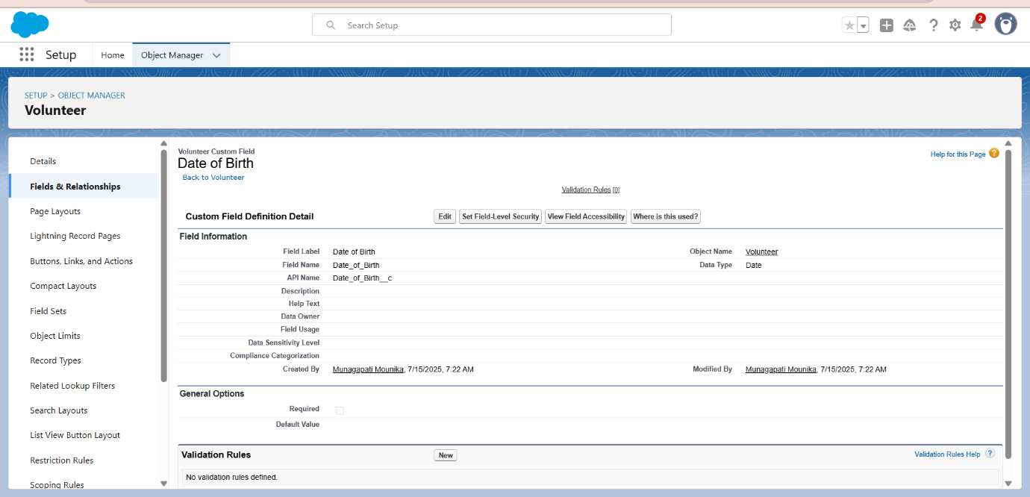

**Creation of fields for the Execution Details object**

1.Go to setup >> click on Object Manager >> type object name(Volunteer) in search bar >> click on the object.

2. Now click on “Fields & Relationships” >> New

3. Select Data type as a “Auto Number” and Click on Next

4. Fill the Above as following:

* Field Label : Execution ID
* Field Name : gets auto generated
* Click on required check box
* Click on Next >> Next >> Save and new.

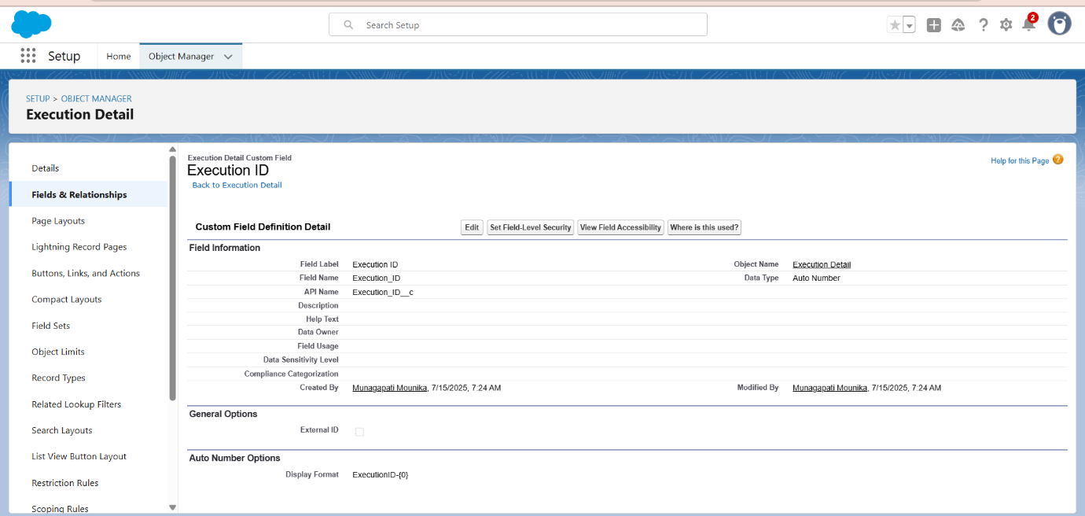

**Create Flow to create a record in Venue object**

1. Go to setup >> type Flow in quick find box >> Click on the Flow and Select the New Flow.
2. Select the Screen flow. Click on create.
3. Click on the ‘+’ icon in between start and end and click on screen element.
4. Under the Screen Properties:

Label: Venue Details

API Name: Venue_Details

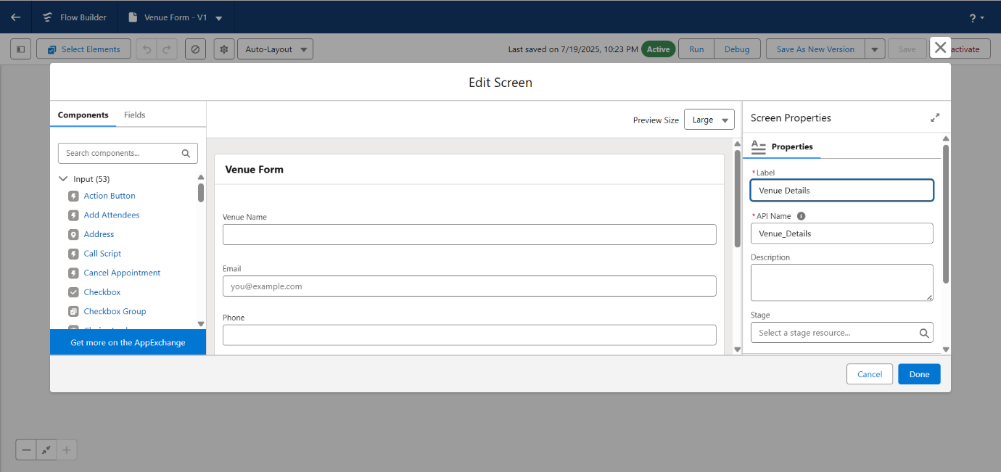

1. Now let’s add components in this flow. Click on Text Component and name it as:

Label: Venue Name

API Name: Venue_Name

1. Click on Email Component and name it as:

Label: Email

API Name: Contact_Email

1. Click on Phone Component and name it as:

Label: Phone

API Name: Contact_Phone

1. Click on Text Component and name it as:

Label: Venue Location

API Name: Venue_Location

1. Click on Number Component and name it as:

Label: Latitude

API Name: Latitude

1. Click on Number Component and name it as:

Label: longitude

API Name: longitude

1. Next click on Done. This would like below
2. Click on the ‘+’ icon in between Venue details and end and click on create record element.
3. Now label it as

Label: Create Venue Record

API Name: Create_Venue_Record

How Many Records to Create: One

How to Set the Record Fields: Use separate resources, and literal values

Object: Venue

Set Field Values for the Venue: Click on ‘Add Field’ 5 times

Field: Value = Contact_Email__c : {! Contact_Email.value}

Field: Value = Contact_Phone__c : {! Contact_Phone.value}

Field: Value = Name: {! Venue Name}

Field: Value = Venue_Location__c : {! location}

Field: Value = Location__Latitude__s : {! latitude}

Field: Value = Location__Longitude__s : {!longitude}

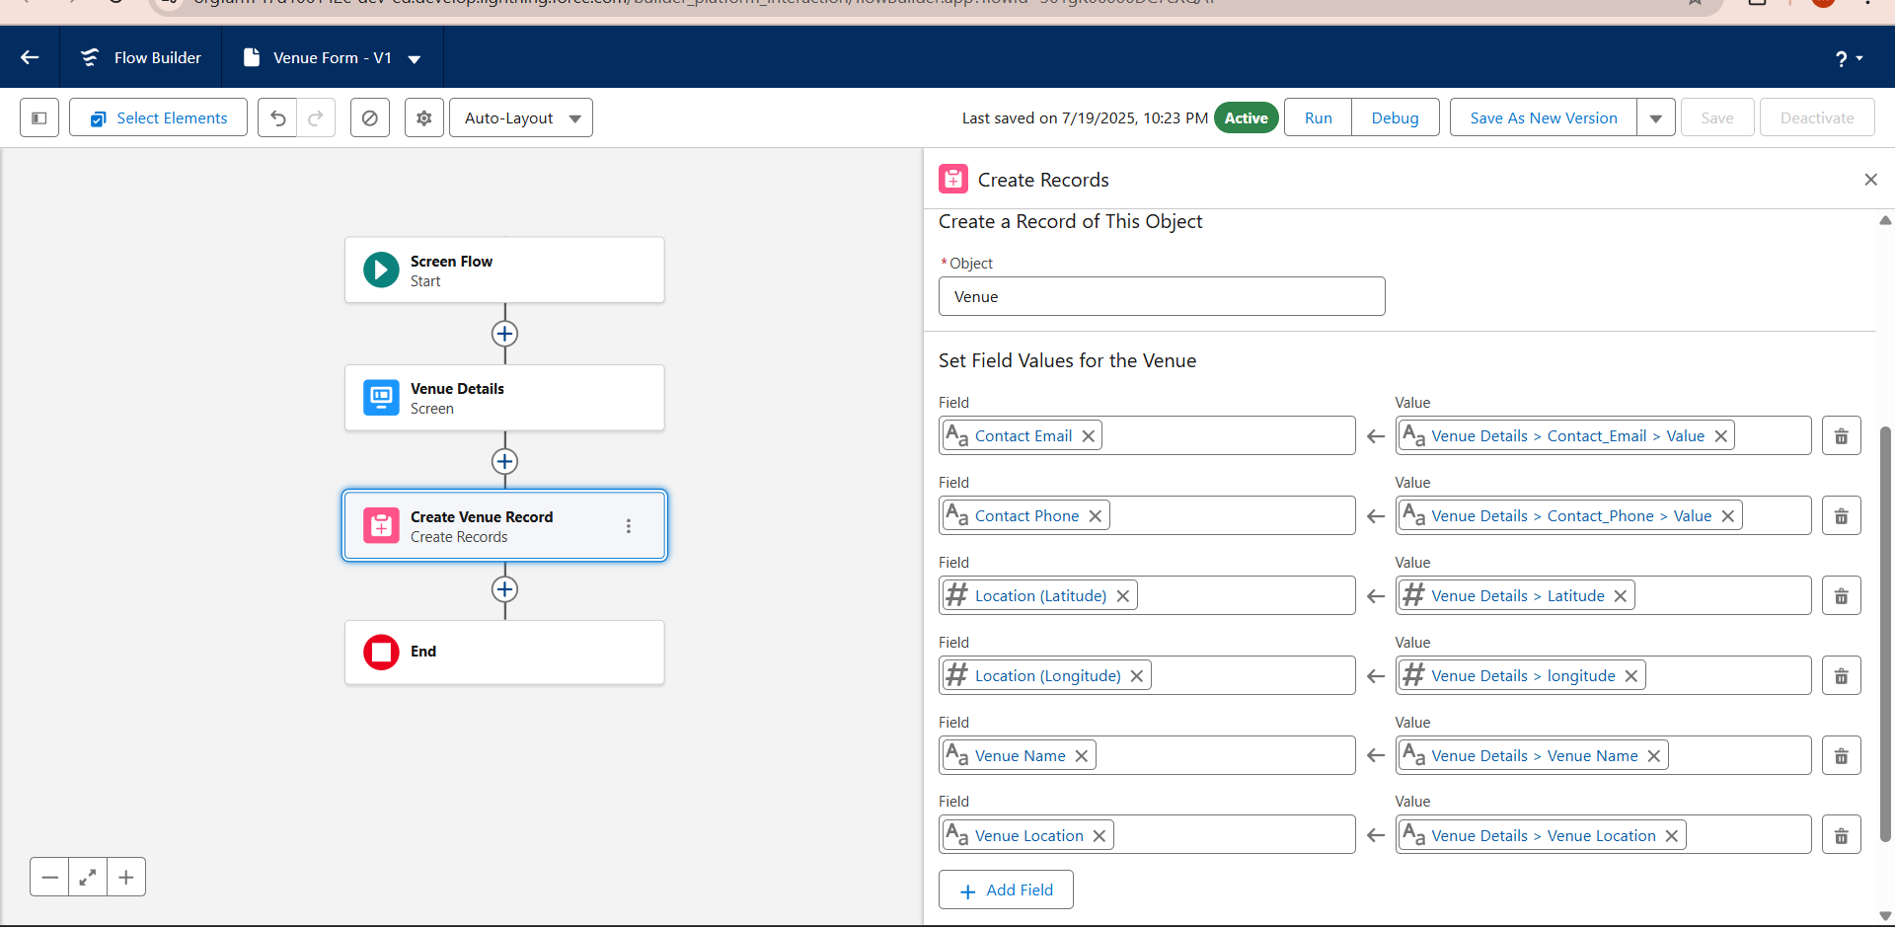

1. This would look like:
2. Click on Save as:

Flow Label: Venue Form

Flow API Name: Venue_Form

**Apex Classes, Triggers, Asynchronous Apex:**

Custom Apex triggers were developed to automatically update stock status and generate distribution records when a pickup is marked completed. Additionally, asynchronous Apex (Batch Apex) was implemented to periodically send summary emails to donors and NGOs highlighting food saved and beneficiaries served over the week. This ensures timely communication and promotes continued engagement without impacting real-time system performance.

**Create a Trigger**

1. Log into the trailhead account, navigate to the gear icon in the top right corner.
2. Click on developer console and you will be navigated to a new console window.
3. Click on the File menu in the toolbar and click on new >> Trigger.
4. Enter the trigger name and the object to be triggered.

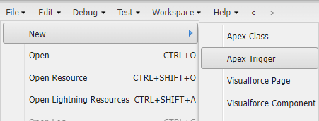

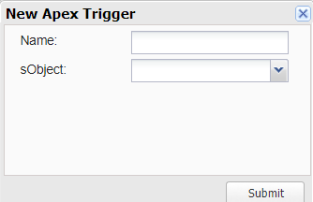

1. Enter Name: DropOffTriggers
2. Object: Drop-Off Point
3. Click on Submit.

**Trigger Code**

(This Trigger is to assign Distance field to the Distance Calculation field. So that we can assign the distance in the sharing rules.)

**Code:**

trigger DropOffTrigger on Drop_Off_point__c (before insert) {

    for(Drop_Off_point__c Drop : Trigger.new){

        Drop.Distance__c = Drop.distance_calculation__c;

    }

}

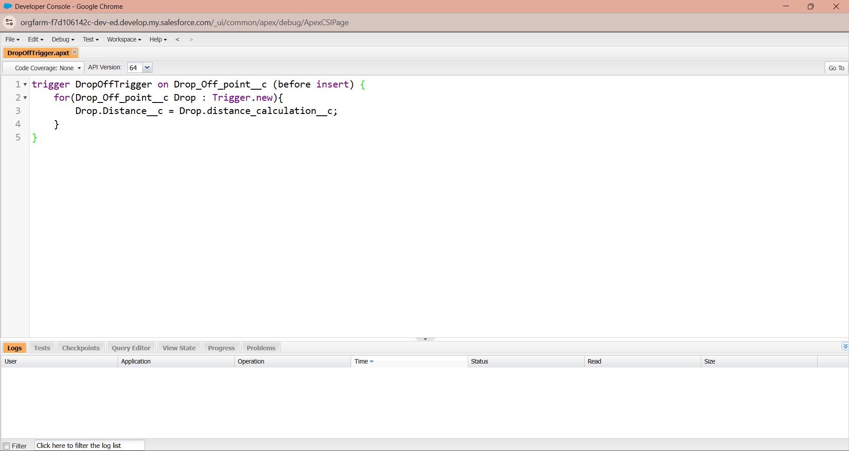

**Phase 3:UI/UX Development & Customization:**

**Create a Lightning App**

To create a lightning app page:

1. Go to setup page >> search “app manager” in quick find >> select “app manager” >> click on new lightning App.

2. Fill the app name in app details and branding as follow App

Name:FoodConnect  
Developer_Name:Thiswillautopopulated  
Image : optional (if you want to give any image you can otherwise not mandatory) Primary color hex value : keep this default.

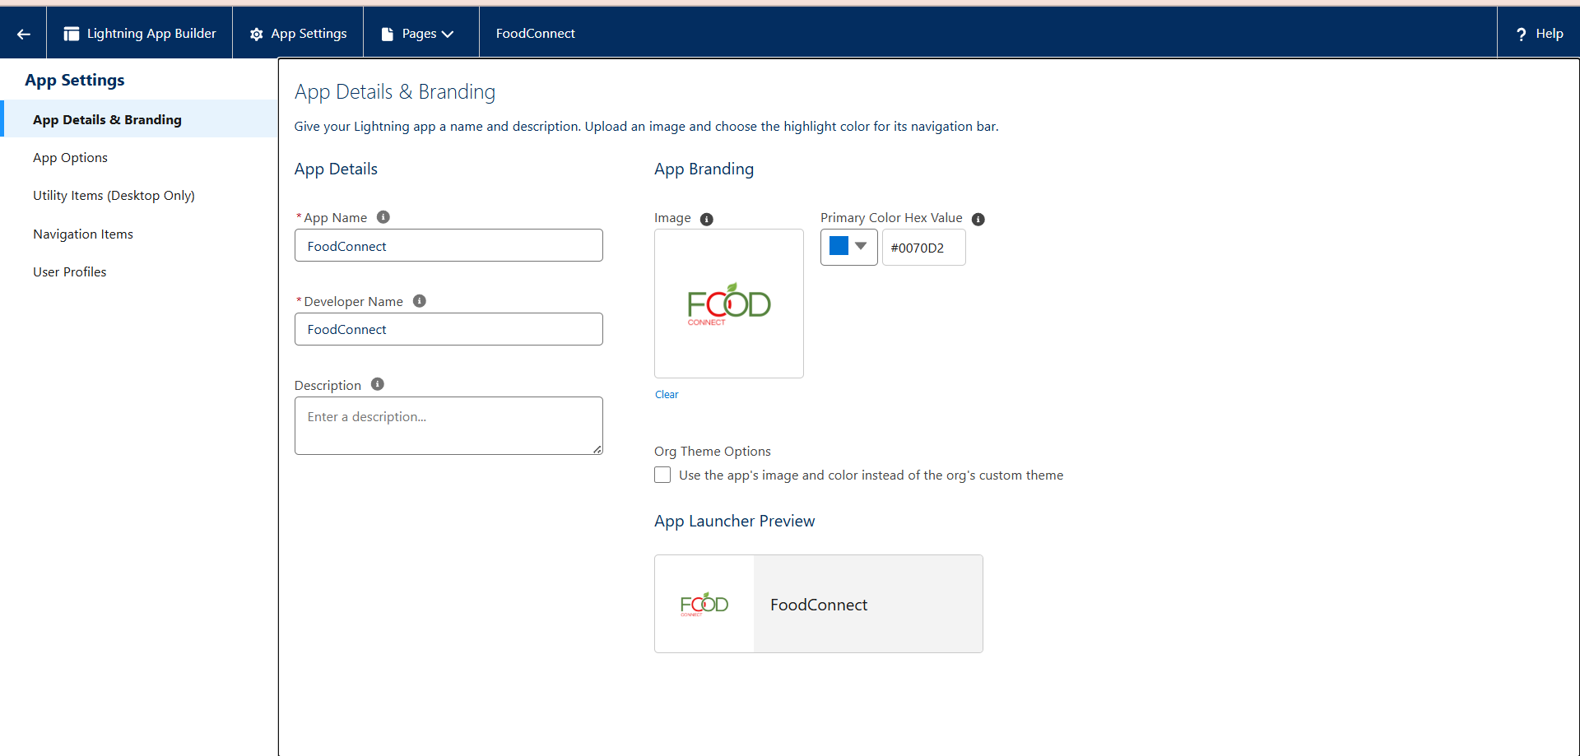

3.Then click Next  >> (App option page)Set Navigation Style as Standard Navigation >> Next.

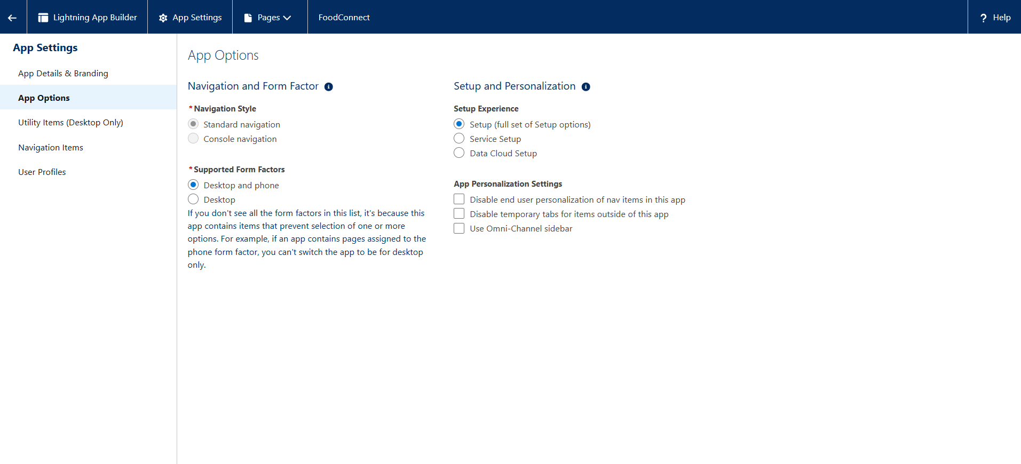4. (Utility Items) keep it as default >> Next.

1. To Add Navigation Items:

Search for the item in the (Home, Venue, Drop-Off Point, Task, Volunteer, Execution Details, Reports) from the search bar and move it using the arrow button >> Next >> Next.

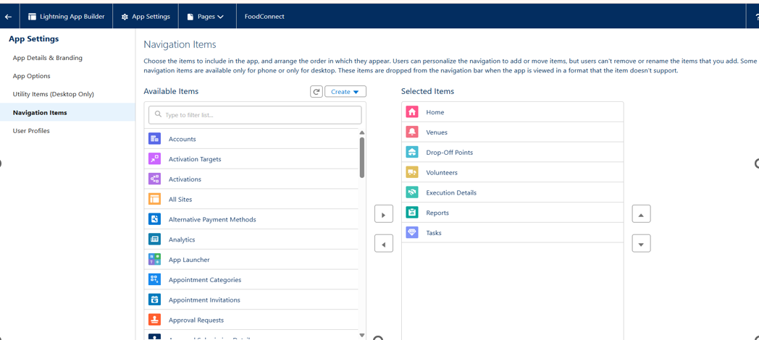

6. To Add User Profiles:

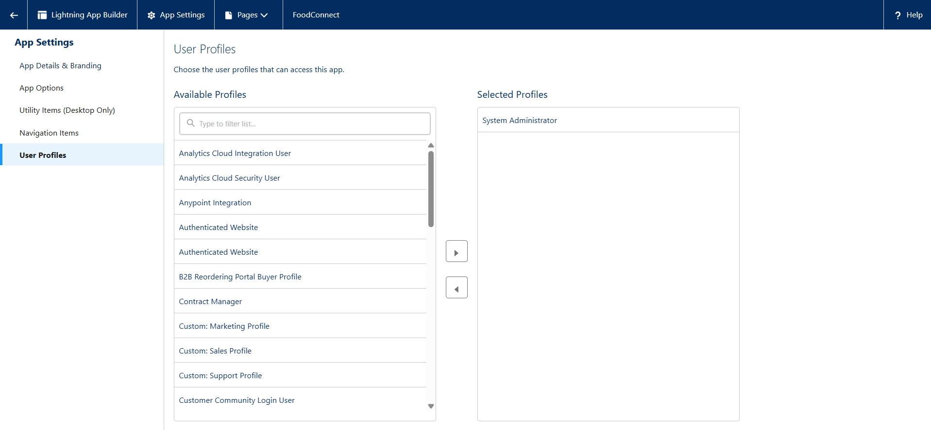

Search profiles (System administrator) in the search bar >> click on the arrow button >> save & finish.

**Creation of Report on Venue with DropOff with Volunteer**

1. Go to the app (FoodConnect)  >>  click on the reports tab
2. Click on New Folder.

Folder Label: Custom Reports

Folder Unique Name: CustomReports

1. Open Custom Reports and click on New Report
2. Select Report Type: Venue with DropOff with Volunteer
3. Then click on Start Report.
4. In GROUP ROWS: Add Volunteer Name
5. In Columns: Add Venue Name, Drop-Off point Name, Distance.

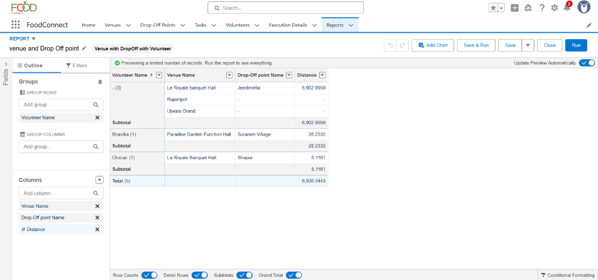

1. Now click on Save & Run.
2. Give Label as:
3. Report Name: venue and Drop Off point
4. Report Unique Name: Auto Populated
5. Click on Select Folder and select Custom Report, then click on Save.

**Creation of Report on Volunteers with Execution Details and Tasks**

1. Go to the app (FoodConnect)  >>  click on the reports tab
2. Click on Custom Reports Folder and click on New Report
3. Select Report Type: Volunteers with Execution Details and Tasks.
4. Then click on Start Report.
5. In GROUP ROWS: Volunteer ID
6. In Columns: Add Volunteer: Volunteer Name, Task: Task Name, Execution Detail : Execution Detail Name, Volunteer: Owner Name, Task: Date, Task : Rating.

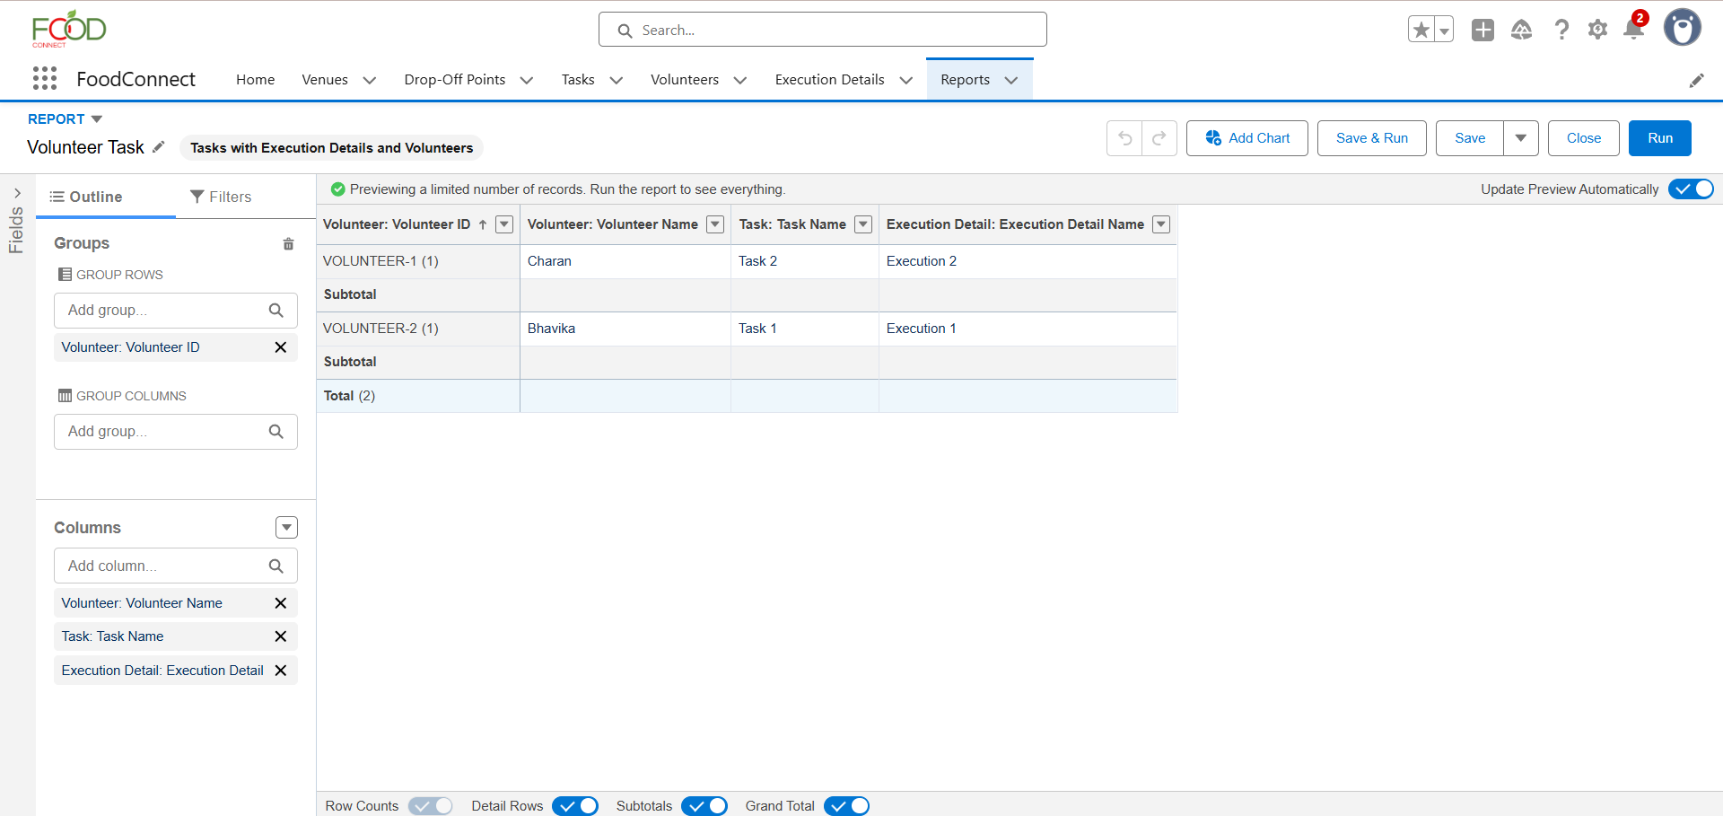

1. Now click on Save & Run.
2. Give Label as:

Report Name: Volunteer Task

Report Unique Name: Auto Populated

1. Click on Select Folder and select Custom Report, then click on Save.

**Adding venue and Drop Off point Report to the Dashboard**

1. Go to the app (Food Connect) >>  click on the Dashboards tab.
2. Click on New Folder.

Folder Label: Custom Dashboards

Folder Unique Name: Auto Populated

1. Open Custom Dashboards and click on New Dashboards
2. Name: Organization Details
3. Click on Widget and select Chart or Table
4. In Select Report: Select venue and Drop Off point Report.
5. Then click on select
6. In Add Component:

Display As: Select Lightning Table

Component Theme: Select Dark (Optional)

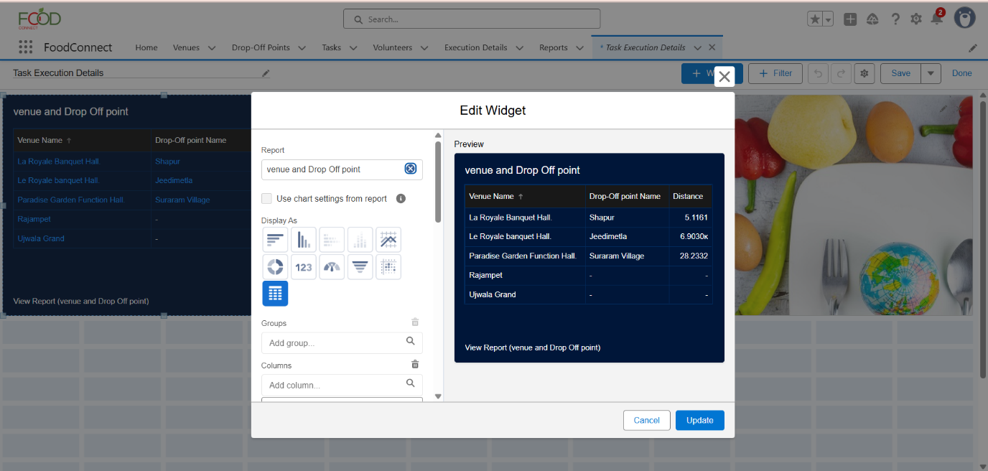

1. Now click on save.

**Adding Volunteer Task Report to the Dashboard**

1. Click on Widget and select Chart or Table
2. In Select Report: Select Volunteer Task Report.
3. Then click on select
4. In Add Component:

Display As: Select Line Chart

Component Theme: Select Dark (Optional)

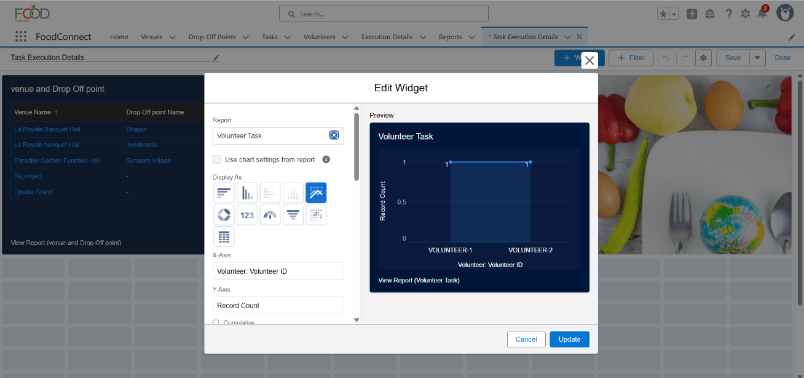

1. Now click on save.

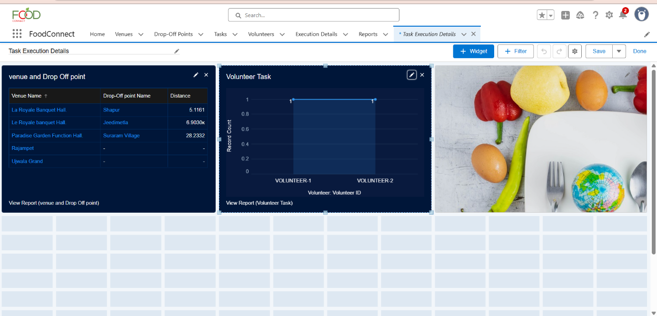

**Phase 4: Data Migration, Testing & Security:**

**Data Loading Process:**Historical data of partner restaurants, NGOs, and past donation records was migrated into Salesforce using the Data Loader, chosen for its capability to handle bulk records and ensure referential integrity across custom objects like Food Donation, Pickup Schedule, and Distribution Record. This ensured a smooth transition from manual tracking systems to the new automated CRM.

**Field History Tracking, Duplicate Rules, Matching Rules:**Field History Tracking was enabled on key objects such as Food Donation and Pickup Schedule to maintain an audit trail of critical changes like pickup time adjustments or status updates. Duplicate Rules and Matching Rules were configured on the Donor and Recipient records to prevent redundant entries and ensure that every partner is uniquely identified, thereby preserving data quality.

**Profiles, Roles, Role Hierarchy, Permission Sets, Sharing Rules:**A robust security model was implemented using Salesforce Profiles and Roles. Profiles controlled baseline access for different users like restaurant managers, NGO coordinators, and volunteer drivers. A Role Hierarchy was established to allow NGO managers to view records of volunteers under them while keeping data compartmentalized across different NGOs. Permission Sets were used to grant additional privileges, such as access to dashboards for analytics teams, while Sharing Rules ensured specific records (like a Pickup Schedule) could be shared with relevant volunteers automatically.

**Profiles**

1. Go to setup page >> type Profiles in Quick Find bar >> click on Profiles >> click on ‘S’
2. Click on Clone beside Standard Platform User.
3. Under Clone Profile:

Profile Name: NGOs Profile

4. Then click on Save

**Profiles**

1. Go to setup page >> type Profiles in Quick Find bar >> click on Profiles >> click on ‘S’
2. Click on Clone beside Standard Platform User.
3. Under Clone Profile:

Profile Name: NGOs Profile

4. Then click on Save

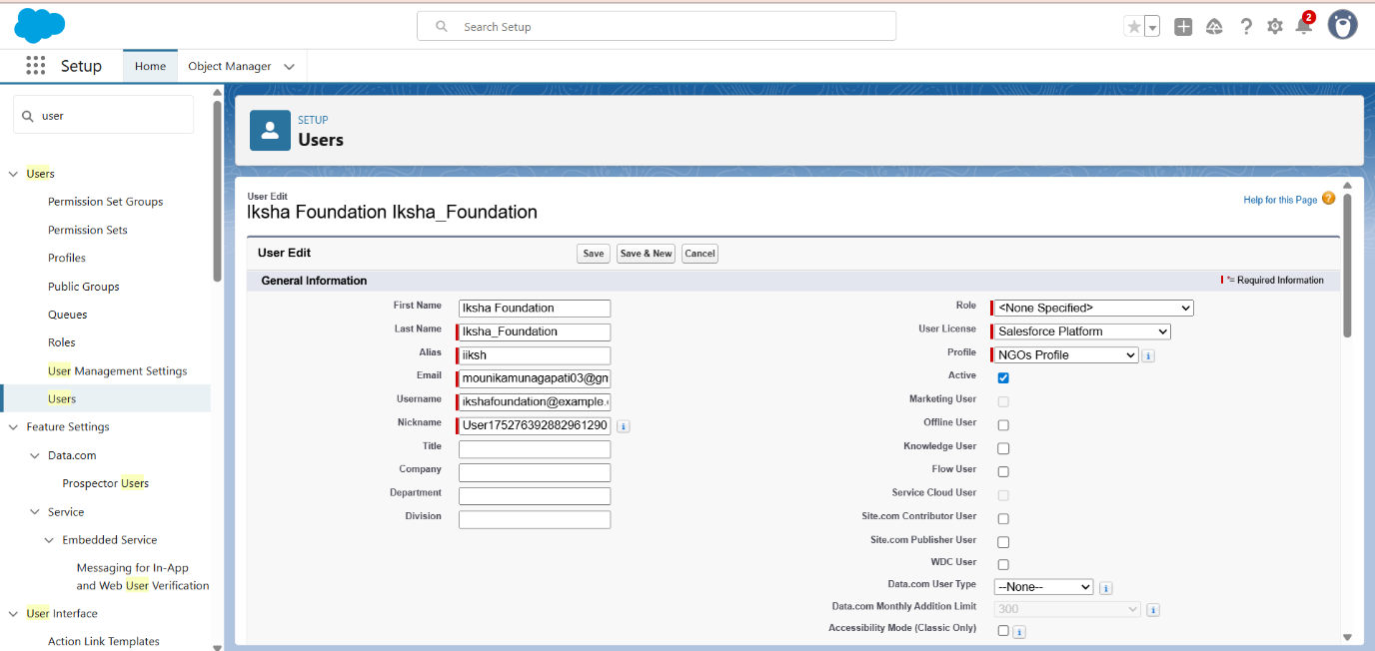

**Creation of User2, User3**

1. Create another Two Users by following steps in Activity - 1 with similar User License and Profile.

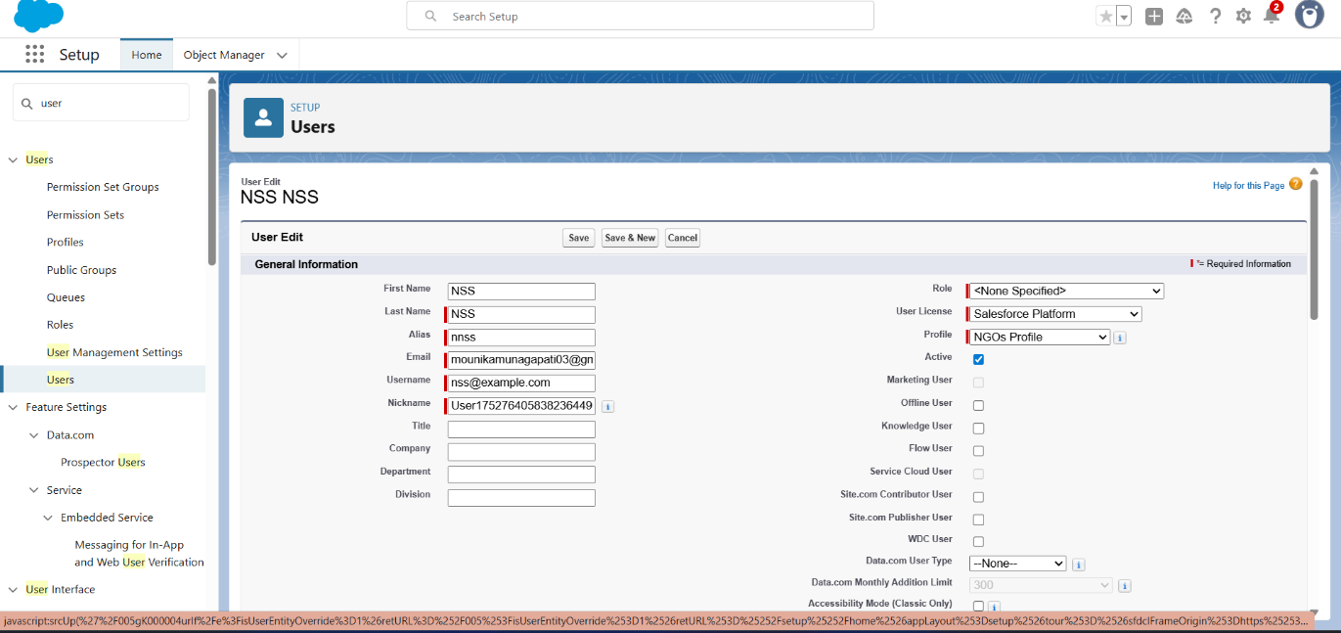

**2.** Give Different First Name, Last Name based on Different NGO’s.

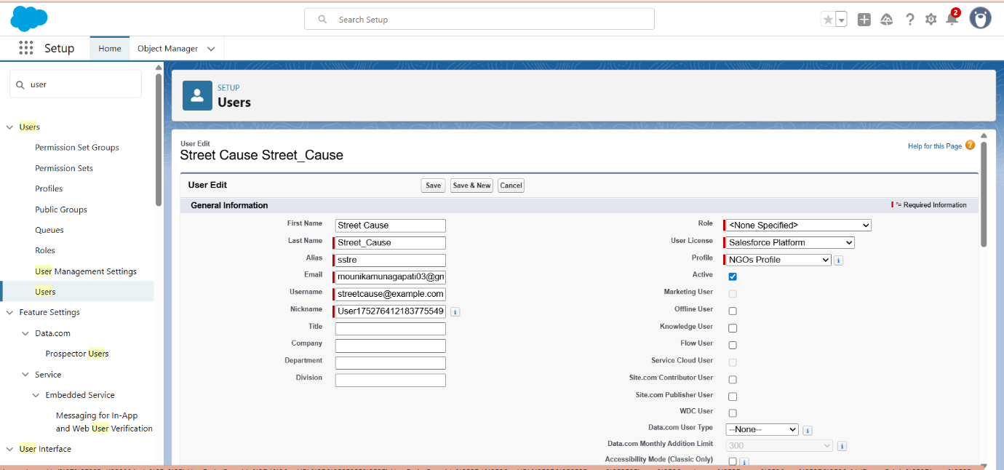

**Creation of sharing rules**

1. Go to setup >> type Sharing Settings in quick find box >>  Click on the Sharing Settings.
2. Scroll down and find Drop-Off point Sharing Rules.
3. Click on new near Drop-Off point Sharing Rules and Name it as:

Label: Rule 1

Rule Name: Rule_1

1. Select your rule type: Select Based on criteria.
2. Select which records to be shared:

Field: Operator: Value = Distance: less than: 15

1. Select the users to share with: Near Share With

Public Groups: Iksha

1. Click on Save.
2. Click on new near Drop-Off point Sharing Rules and Name it as:

Label: Rule 2

Rule Name: Rule_2

1. Select your rule type: Select Based on criteria.
2. Select which records to be shared:

Field: Operator: Value = Distance: greater than: 15

Field: Operator: Value = Distance: less or equal: 30

1. Select the users to share with: Near Share With

Public Groups: NSS

1. Click on Save.
2. Click on new near Drop-Off point Sharing Rules and Name it as:

Label: Rule 3

Rule Name: Rule_3

1. Select your rule type: Select Based on criteria.
2. Select which records to be shared:

Field: Operator: Value = Distance: greater than: 30

Field: Operator: Value = Distance: less or equal: 50

1. Select the users to share with: Near Share With

Public Groups: Street Cause

1. Click on Save.

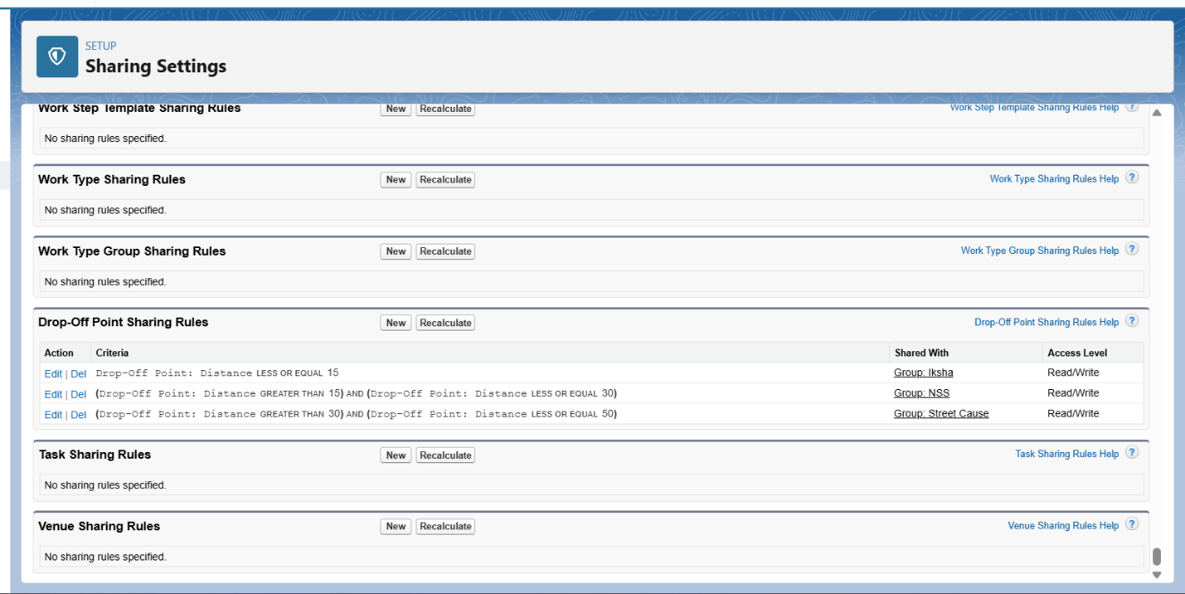

**Phase 5: Deployment, Documentation & Maintenance:**

**Deployment Strategy:**  
The deployment of the FOODCONNECT CRM from the sandbox environment to production was carried out using **Change Sets**, which facilitated secure and organized migration of metadata components including custom objects, fields, validation rules, flows, and Apex code. This method ensured that all dependencies were properly packaged and tested before final deployment, minimizing the risk of disruptions in the live environment.

**System Maintenance and Monitoring:**  
The CRM is designed for ease of ongoing maintenance. Scheduled reports and dashboards help monitor daily operations, highlighting metrics like pending pickups and distributions completed. Regular data quality reviews are performed to identify duplicates or

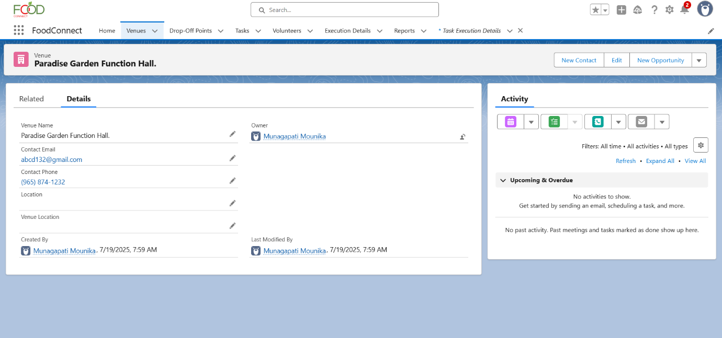

inconsistencies. Admins are responsible for periodic reviews of automation processes and ensuring that validation rules and flows continue to align with evolving business

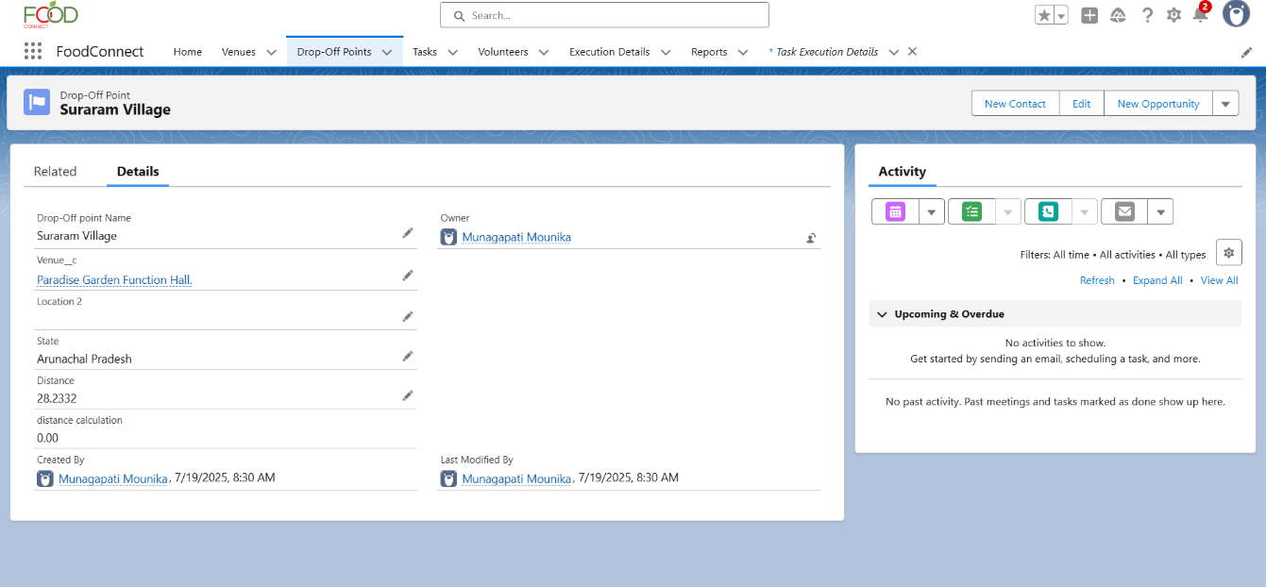

requirements. Any required enhancements or new features will be safely developed and tested in sandbox environments before being pushed to production.

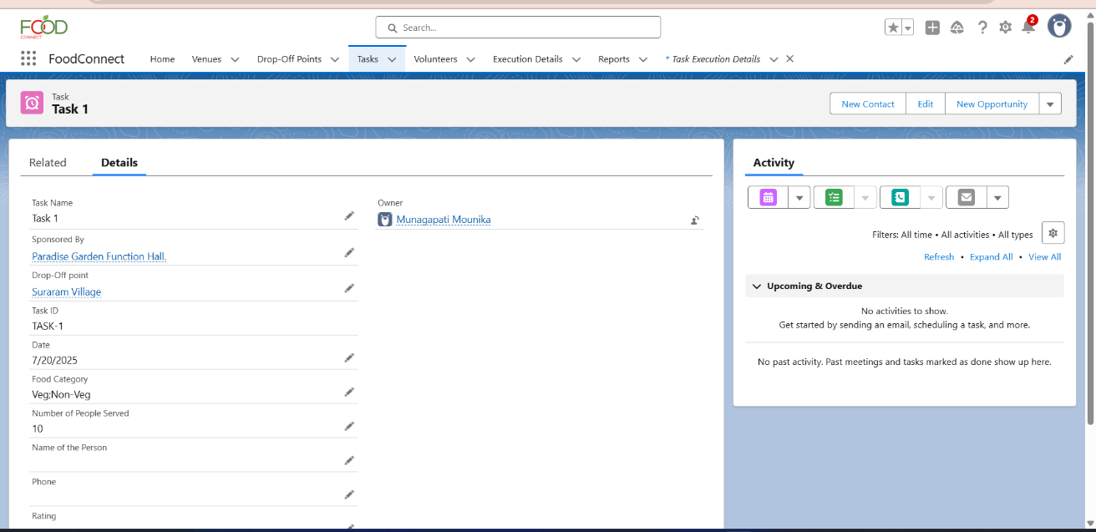

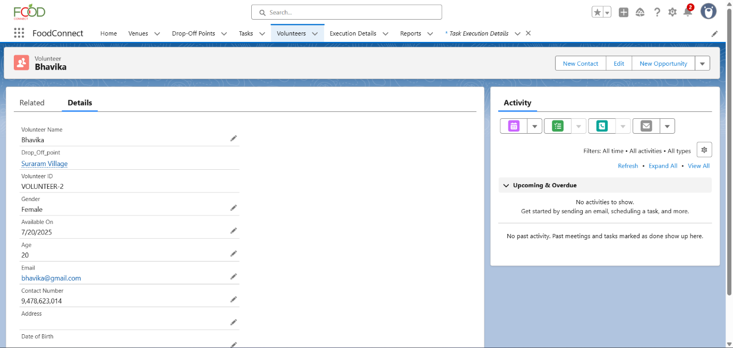

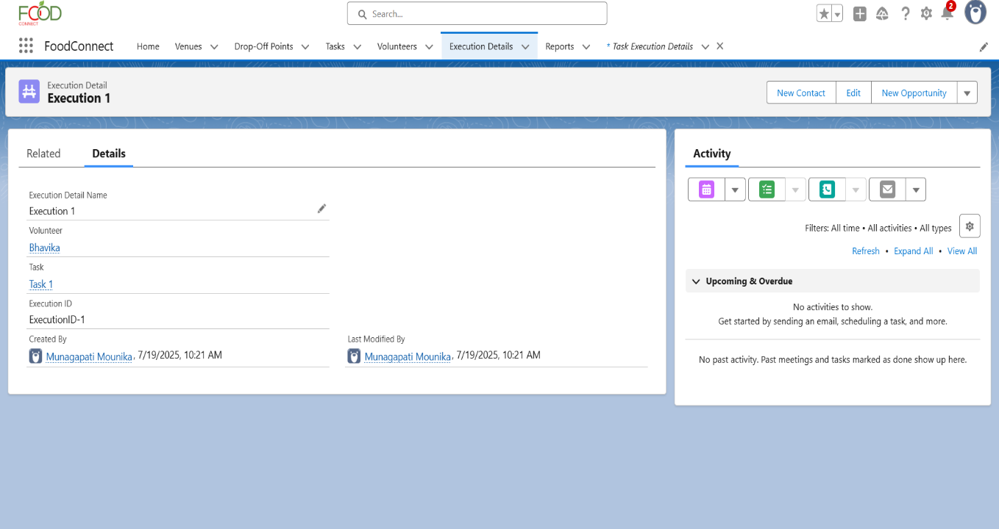

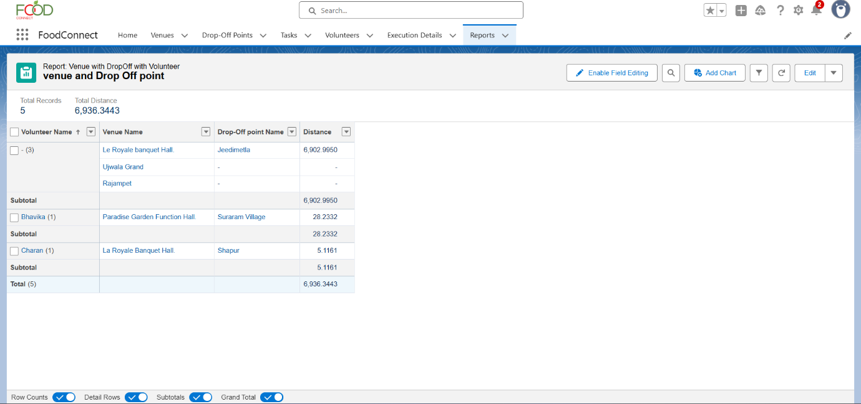

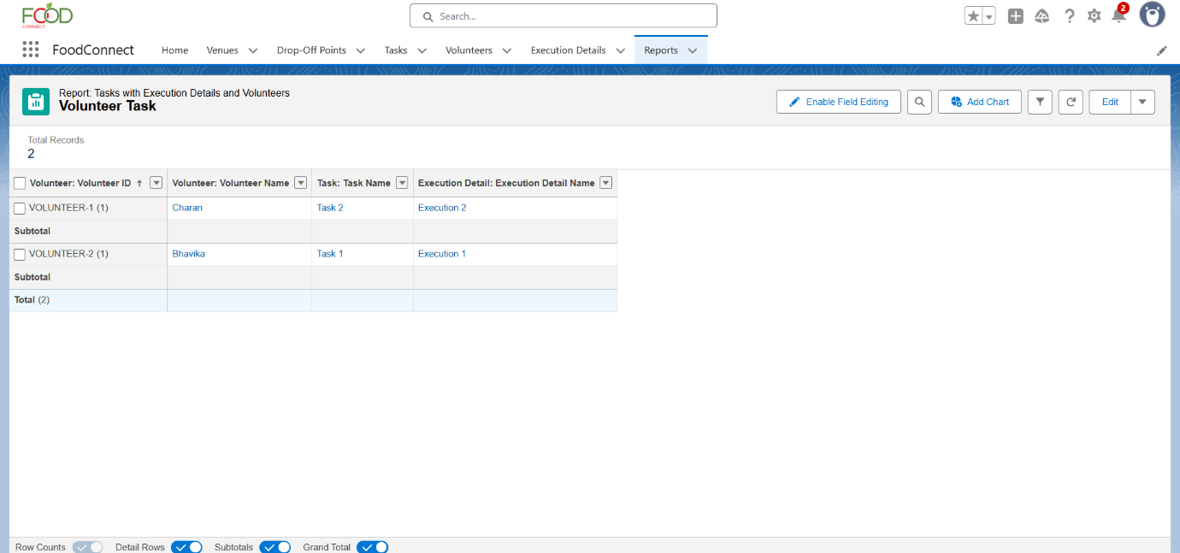

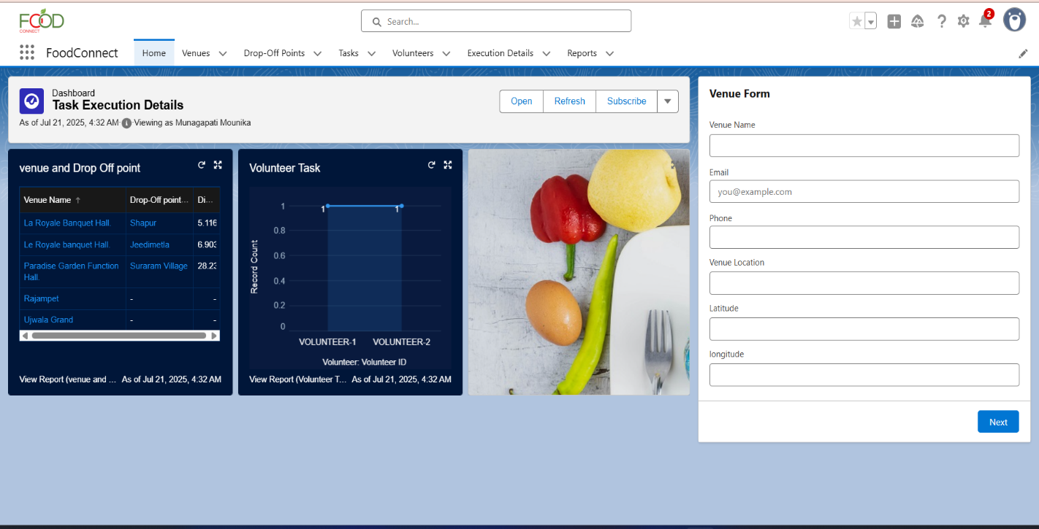

**Troubleshooting Approach:**

During the development of the *Food Connect* platform using Salesforce, a structured troubleshooting process was followed to ensure system reliability and user satisfaction. Issues were identified through continuous testing, user feedback, and monitoring tools such as debug logs and error notifications. Each problem was categorized as configuration-related, code-related, data-related, UI/UX, or performance-based. Root cause analysis involved reviewing system logs, user permissions, and automation flows to isolate errors. Solutions included fixing validation rules, updating Apex logic, correcting data, optimizing queries, and adjusting user interface settings. Problems were tested and resolved in sandbox environments before deployment. All issues and resolutions were documented, and preventive measures like validation rules, alerts, and enhanced test coverage were implemented to avoid recurrence and maintain platform stability.

**Conclusion:**

The *Food Connect* project successfully demonstrates how technology can be leveraged to address critical social challenges such as food wastage and hunger. By building the platform on Salesforce, we were able to utilize powerful tools for data management, automation, and user access control to create an efficient and scalable system. The application enables seamless coordination between food donors and volunteers, ensuring that surplus food is redirected to those in need in a timely and organized manner. Through the use of real-time tracking, notifications, and user-friendly interfaces, the platform enhances transparency, encourages community participation, and promotes social responsibility. The project not only meets its functional and technical objectives but also creates a foundation for future enhancements such as mobile access, AI-driven matching, and integration with larger relief networks. Overall, *Food Connect* stands as a meaningful, technology-driven solution that makes a real-world impact.